**Jenkins Installation:**

Firstly download jenkins in your PC. You can download jenkins from below mentioned link.

<https://www.jenkins.io/download/>

After opening above mentioned link click on download jenkins for Windows and download will start automatically.

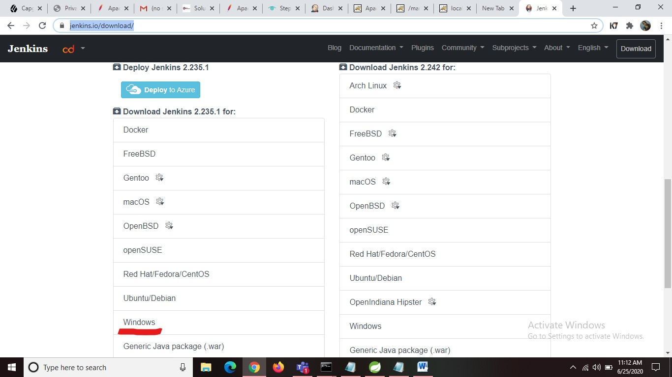

Open the downloaded zip file and extract it. Later open the extracted file and click on jenkins installer file and install the jenkins.

By default jenkins run on port number 8080. So after successful installation you can check port number 8080.

**Creation of .war file in STS or Eclipse using maven-war-plugin:**

**Step -1**

Open your pom.xml file and add below lines of code and save changes.

<packaging>war</packaging>

<dependency

<groupId>org.apache.maven.plugins</groupId>

<artifactId>maven-war-plugin</artifactId>

<version>3.3.0</version>

</dependency>

**Apache Tomcat Installation:**

Click on the below link

<https://tomcat.apache.org/>

Scroll down a little to locate and click on the [Tomcat 9 link](https://tomcat.apache.org/download-90.cgi) located within the left menu bar.

Next, locate the [32-bit/64-bit Windows Service Installer](https://www-eu.apache.org/dist/tomcat/tomcat-9/) link and click on it.

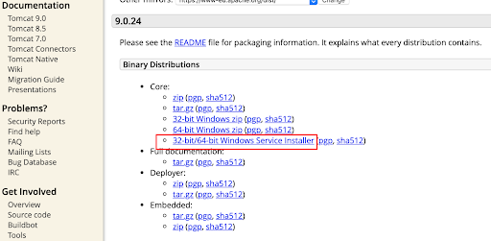

By clicking on it download will be automatically started. Open the downloaded installer and start installing tomcat in your pc.

Please change the port at configuration step of installation because tomcat default porst number is also 8080 as jenkins is already running in 8080 change the port number and set username and password.

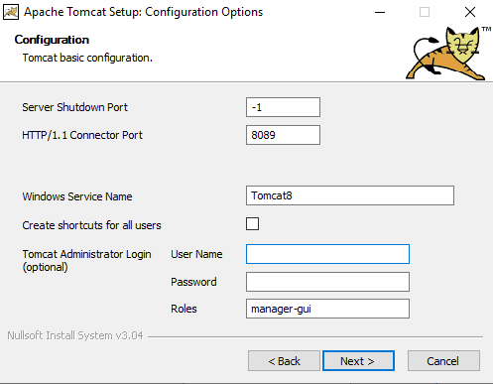

Continue installing tomact after successful installtion you can see tomcat running in port numver that you have specified.

**Jenkins Tomcat deploy of a war file:**

**Step-1**

Open <http://localhost:8080/> where jenkins is running.

Click on **Manage Jenkins** link located within the left menu bar. And in the **System Configuration** click on **Global Tool Configuaration.**

Later click on **JDK installations..** and in the **JAVA_HOME** field provide your jdk local path and the **name** can be any thing. Can refer through below image.

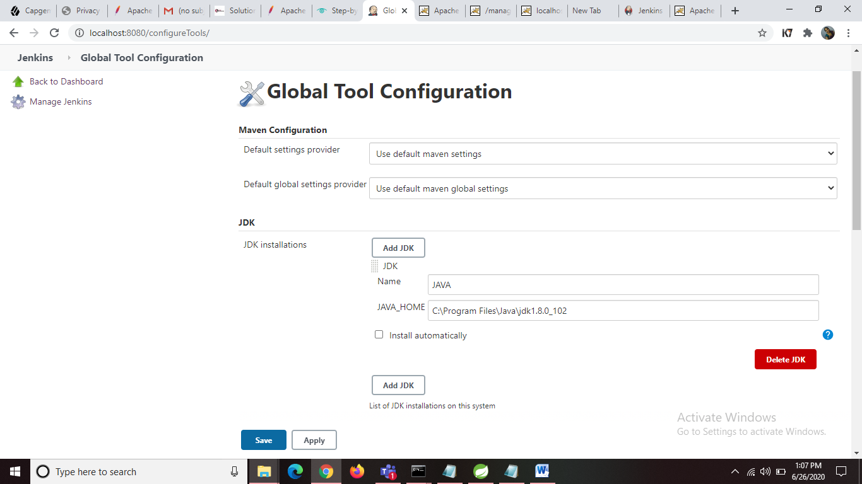

Later in **Maven** click on **Maven** **installations** and in the **MAVEN_HOME** fileld provide your maven path and the **name** can be any thing. Can see in the below image.

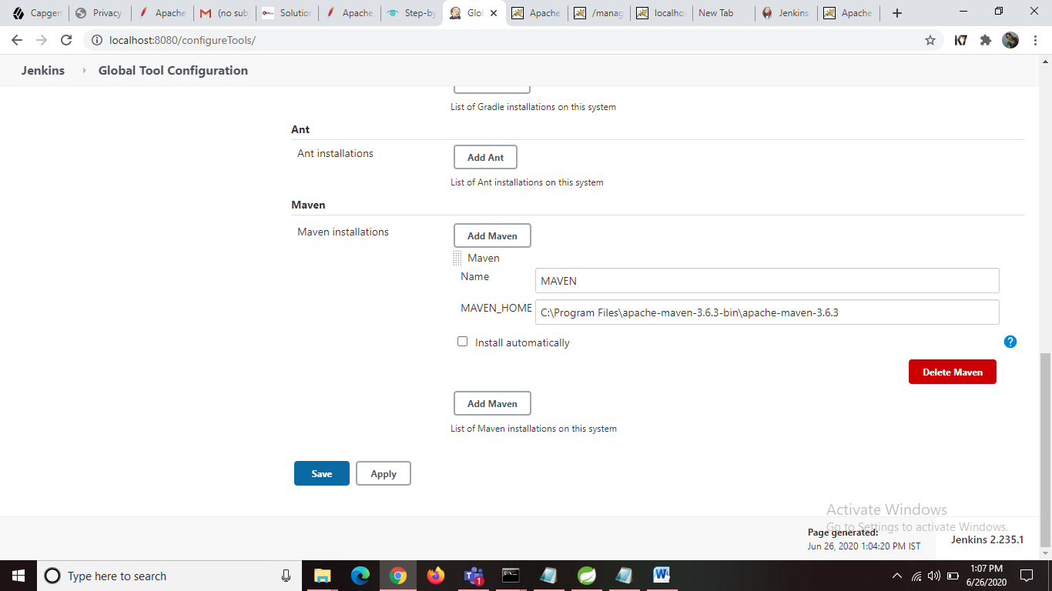

Click **Apply** button and click on **save**.

Go back to Jenkins home page.

**Step-2**

Click on New Item link located within the left menu bar.

Enter an item name that you want to give for your project. Click on Freestyle project and then click on OK button.

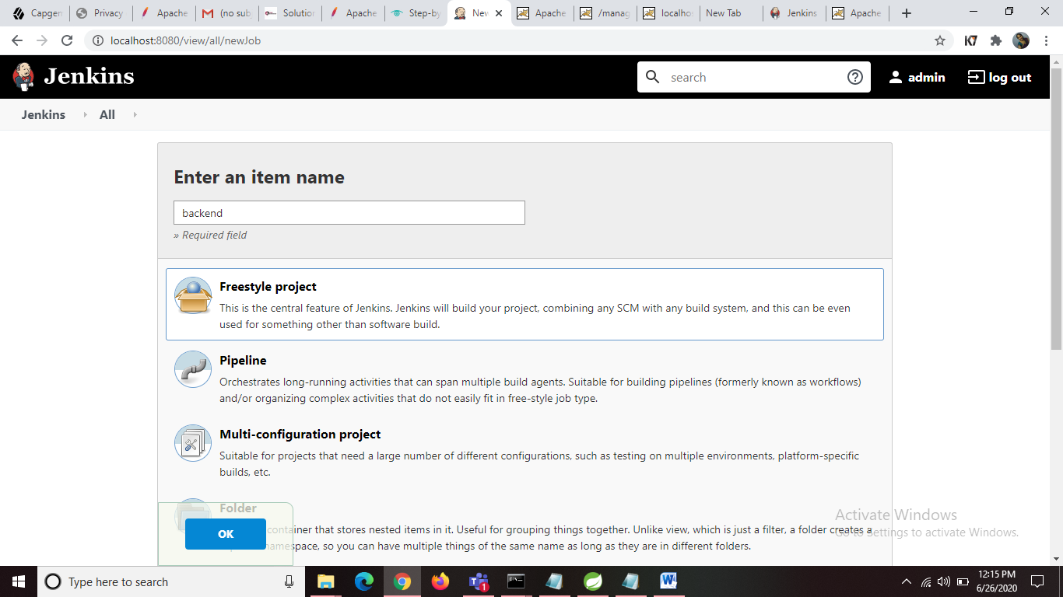

**Step-3**

Go back to jenkins home page there you can see your project. Open your project and click on configure link located within the left menu bar.

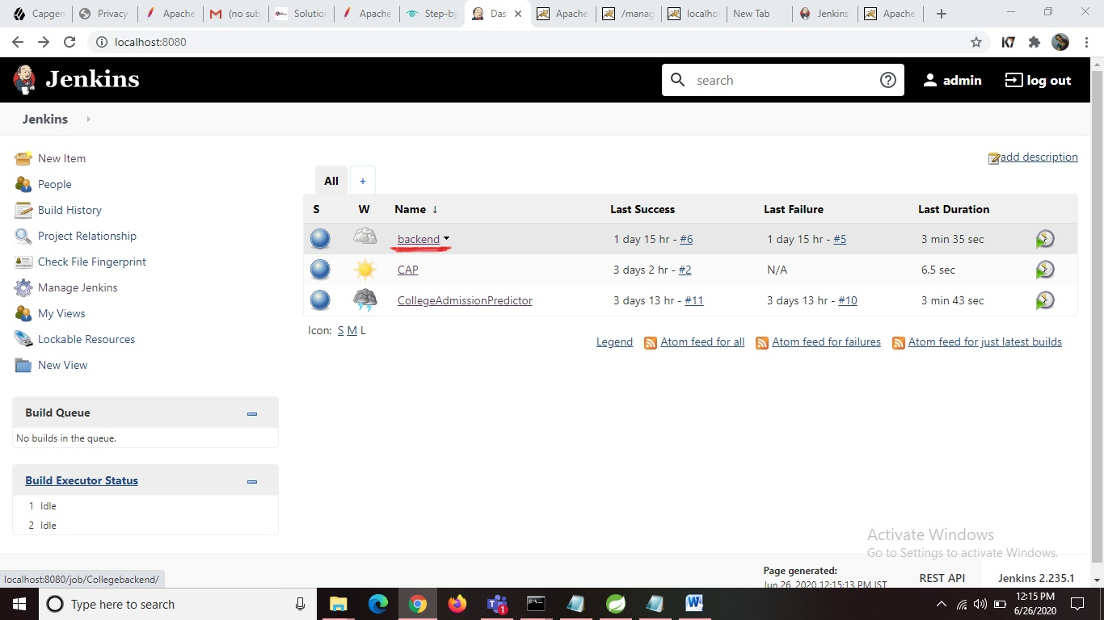

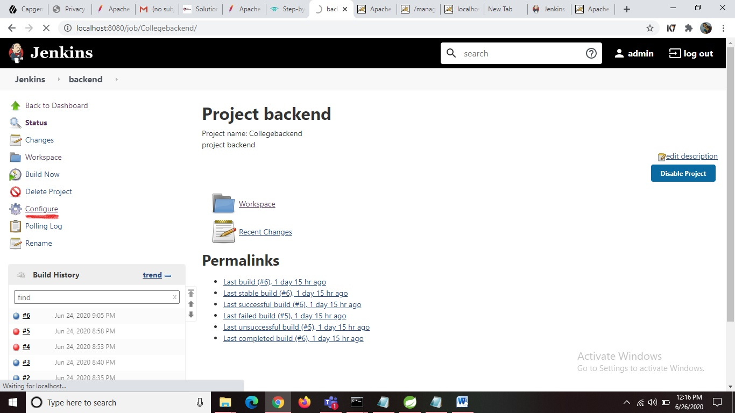

Then you will be redirected to a page where you need do some configurations. In the **General** section you can see a **description** text box enter description about your project.

Later if you scroll down you can locate a **Advanced** button click on the button and later select Use **custom workspace** as shown in the below figure and provide your project location in the **Directory** field and the **Display name** can be any thing.

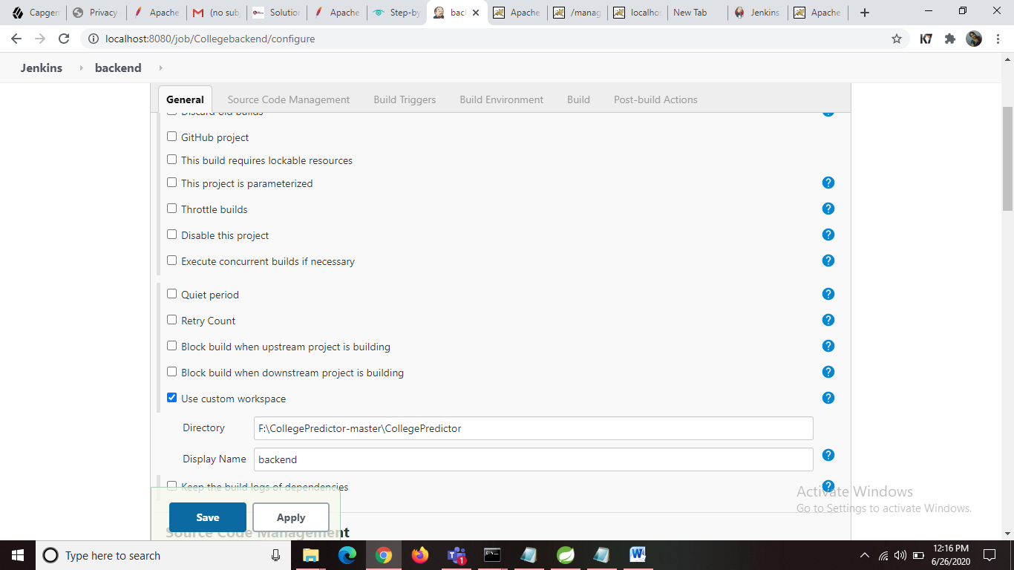

Down to that you can locate **Source Code Management** in that select **None.** As shown in the below image.

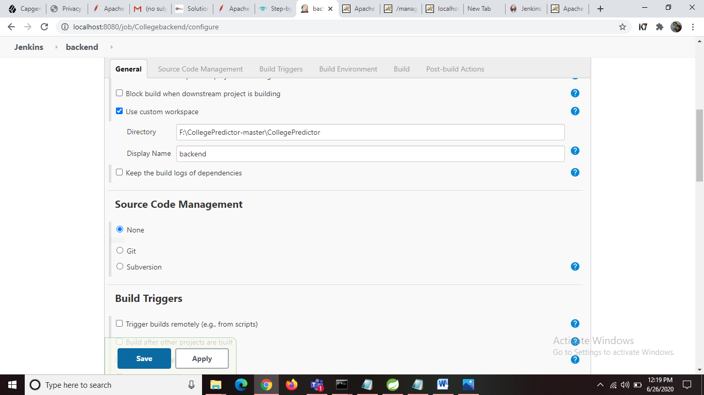

Down to that you can locate **Build Triggers** in that select **poll SCM** and in the **Schedule** text box enter 5 stars with space (* * * * * ) as shown in the below image.

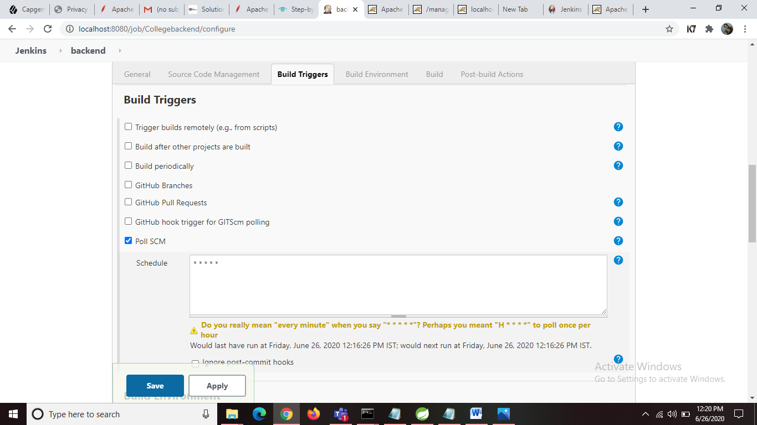

Later if you scroll down you can locate **Build** in that click on **Add build setup** button and select the **Maven Version** from the drop down and in the **Goals** field enter package. As shown in the below image.

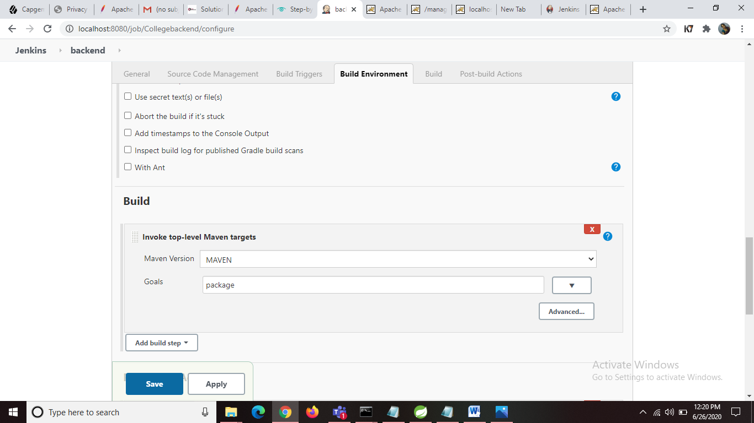

Click on **Apply** button and later click on **Save.**

Go back to jenkins home page.

**Step-4**

Open your project by clicking on your project name displayed in jenkins home page.

Click on **Build Now** link located within the left menu bar. Then project biuld will be started you can see it in **Build History** located below the left menu bar. As shown in the below image.

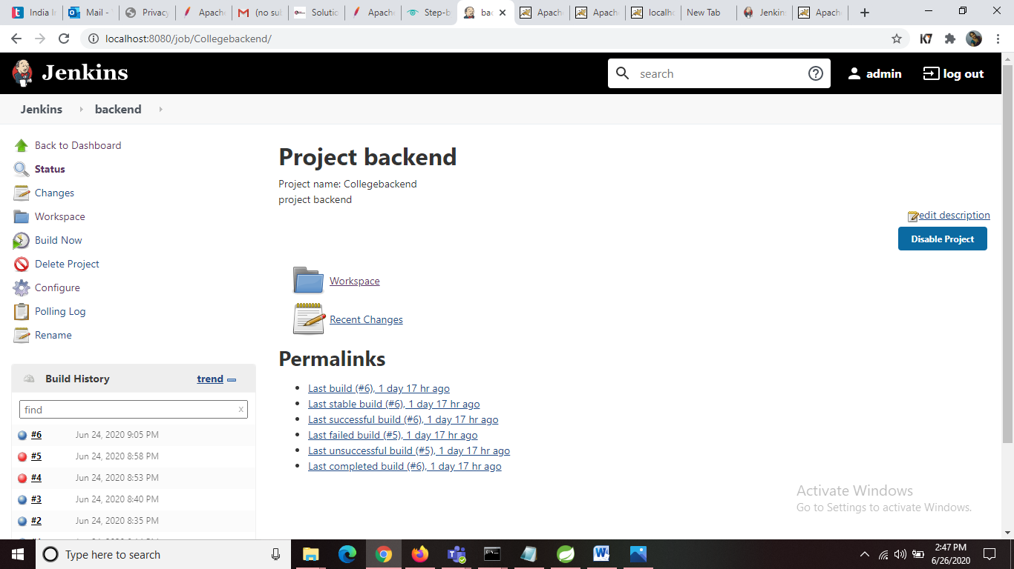

Later click on specific build and click on Console Output there you can see your build output as show in the below image.

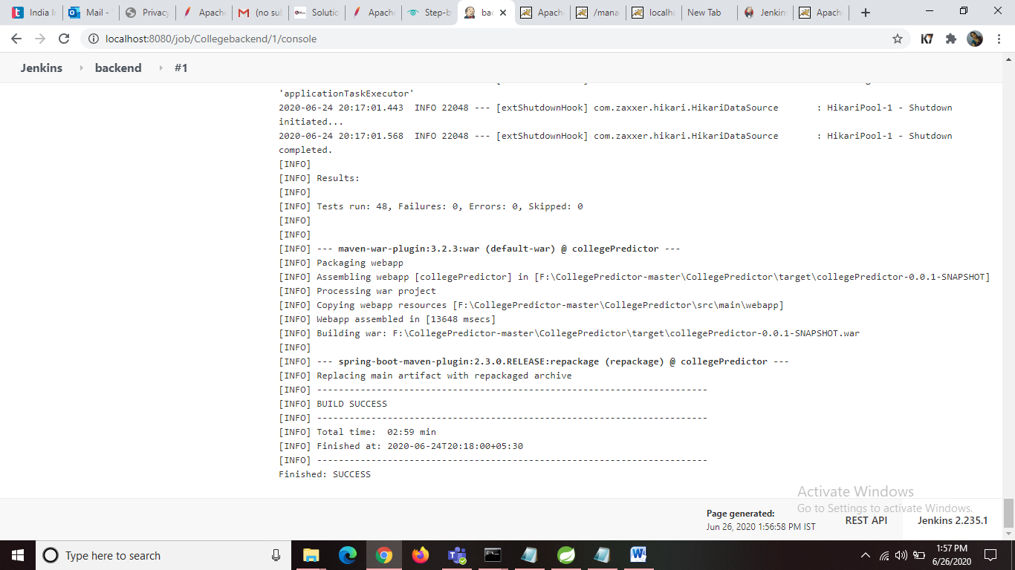

After successful build you can see a war file generated in target folder of your work space. As shown in below image.

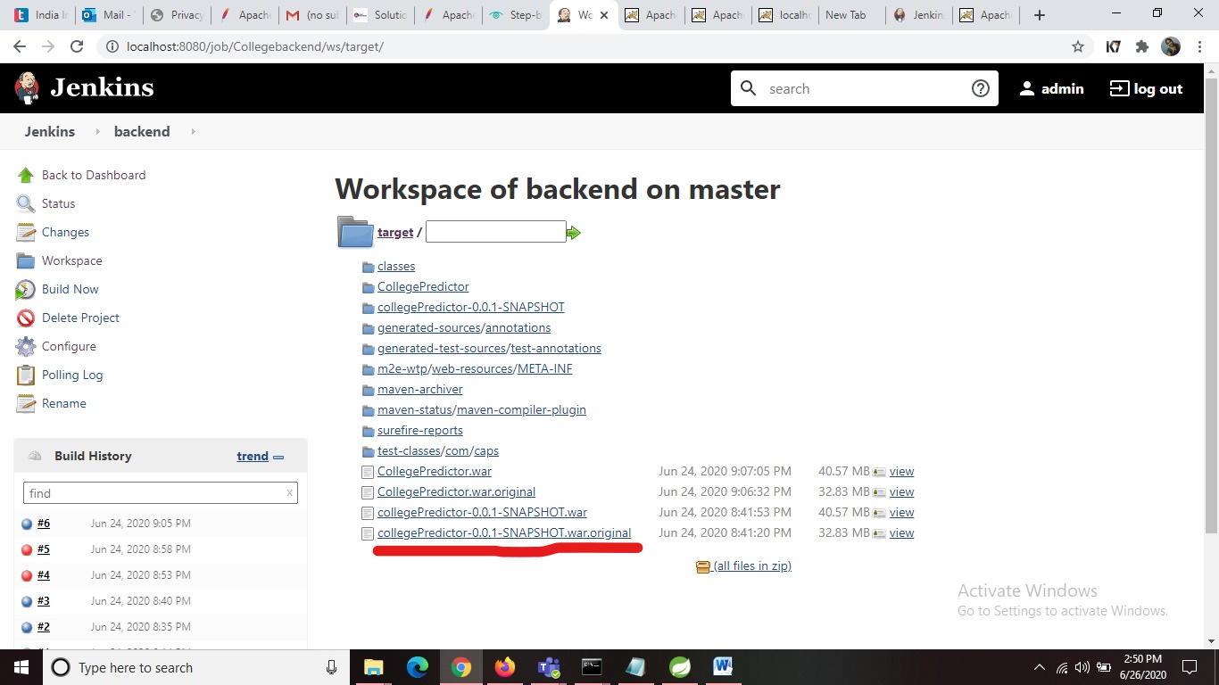

**Step-5**

Now you have to deploy war file on Tomcat using jenkins for that you need to add below line in

Tomcat server folder🡪 conf 🡪 tomcqat-users.xml and change username and password.

<user username="admin1" password="admin" roles="manager-script" />

Now open jenkins home page and click on **Manage Jenkins** link located within the left menu bar. And Select **Manage Plugins** and in the **Available** section search for deploy and sele**ct Deploy to container Plugin** and click on**Install without restart.**

Later open project **configure** and scroll down at last you can see **Post-build Actions** in that click on **Add post-build action** and in **WAR/EAR files** field give your war file name in the **context path** field give any name. In containers add **Tomcat URL** where your tomcat is running and Add **credentials** that you have added in the file in previous step. As shown in the below image.

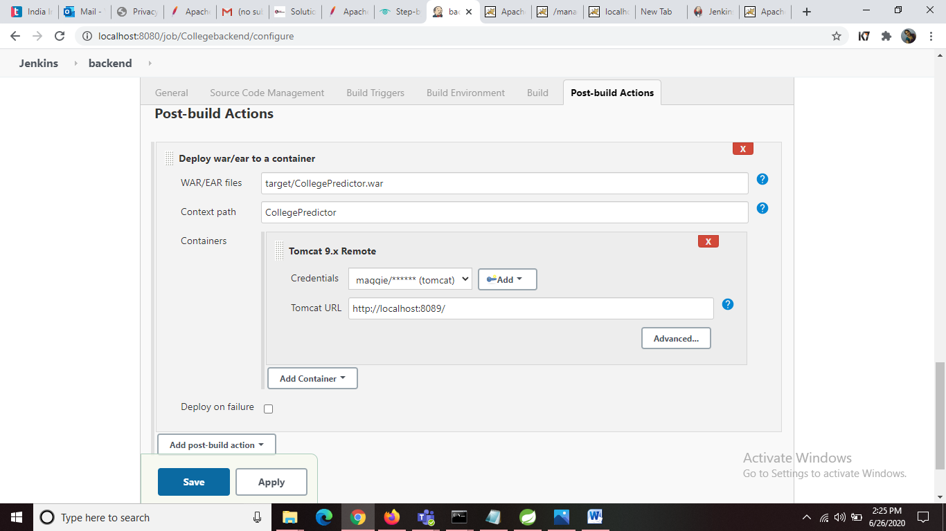

Click on **Apply** and click on **Save**.

**Step-6**

Go back and Click on **Build Now**.

If the Console Output you can see the result as shown in the below image.

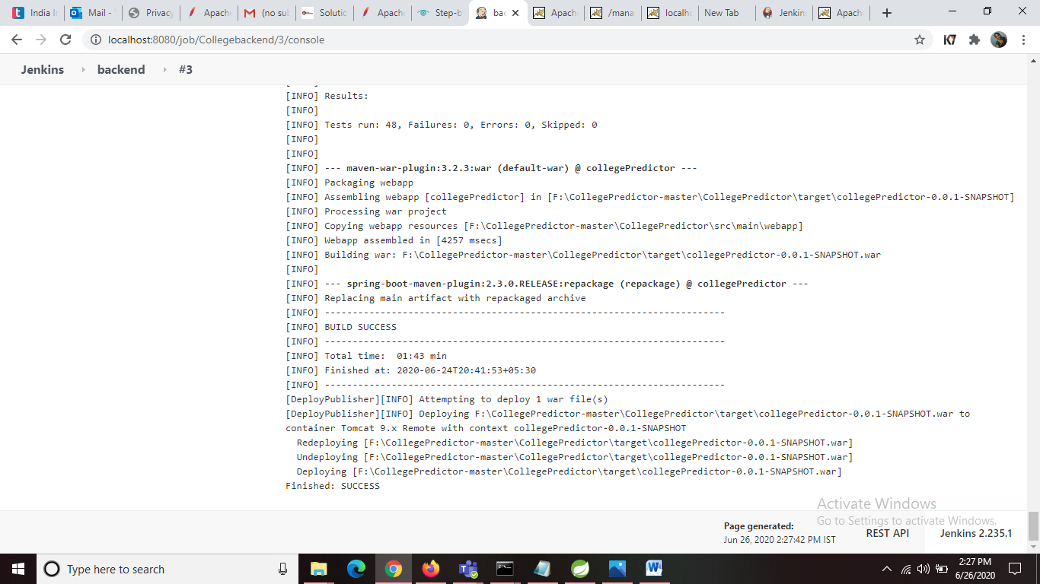

If the Build is success open localhost where your tomcat is running and click on **Manager App** button located in the right side as shown in the below image.

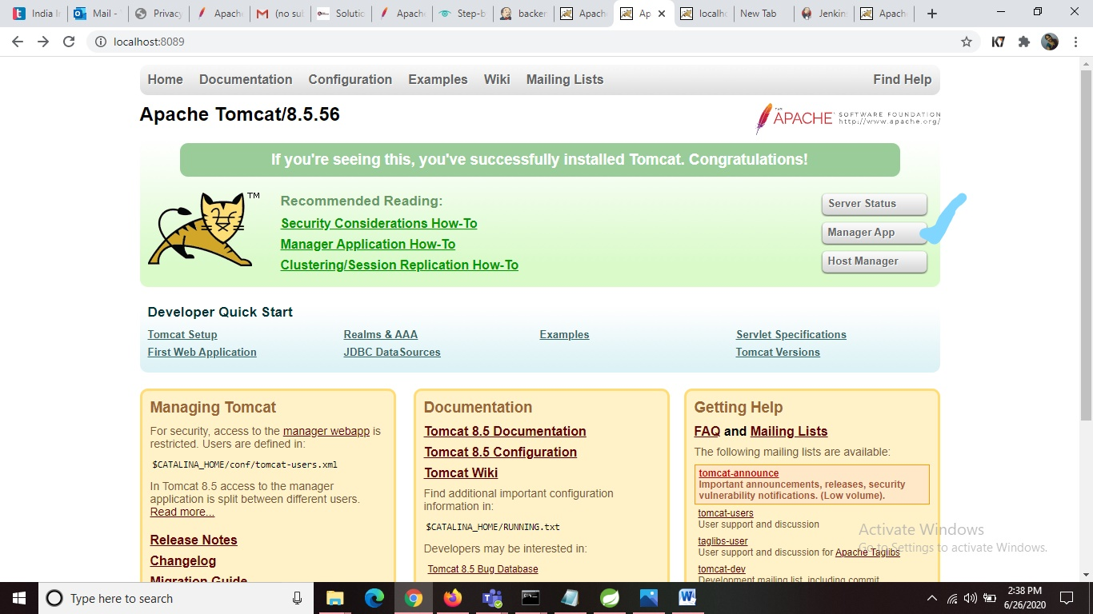

Then Tomcat Web Application Manager page will be opened. There in the Apllications path you can see your project war file name that is deployed. As shoen in the below image.

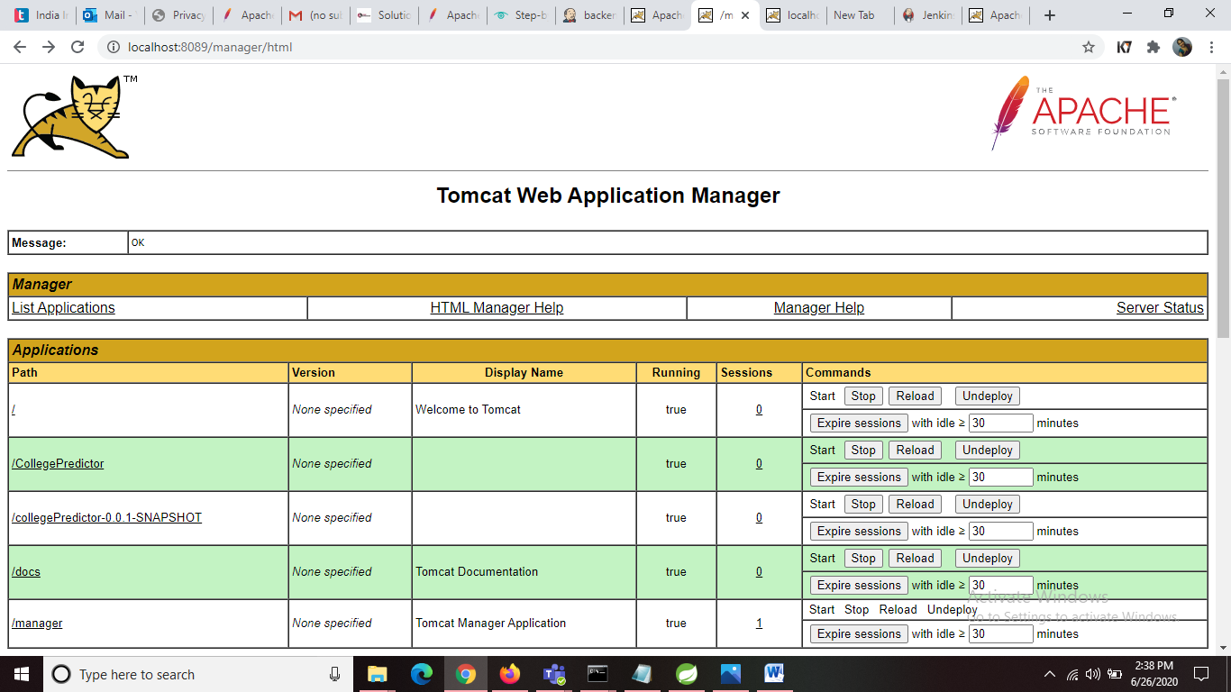

You can check its working by opening the link like below mentioned link for your project. Then you can view the result of your functionality.

<http://localhost:8089/CollegePredictor/getAllcolleges>

SonarQube

**Jenkins**

Jenkins is an open source Continuous Integration system. It is a process in which developers puts their code in a shared repository and every time the automated cycle is performed from Build, Test and Deploy, etc.

**SonarQube**

SonarQube Integration is an open source static code analysis tool that is gaining tremendous popularity among software developers. It enables software professionals to measure code quality, identify non-compliant code, and fix code quality issues.

SonarQube enables developers to track code quality, which helps them to ascertain if a project is ready to be deployed in production. Further, it allows developers to continuously inspect the code, perform automatic reviews and run analysis to find code quality issues.

**Why should Integrating SonarQube and Jenkins Useful:**

When you are working on a project and if are doing SonarQube analysis sometimes then you can do that easily but if the scenario changes to that SonarQube analysis will be performed after completion of each and every task or say deployment then the manual action would become hard to rely on. So, to overcome the problem of manual analysis with it,

SonarQube is integrated with Jenkins which performs automated tasks. Now, you have to only add your sonar script for analysis in Jenkins job to perform SonarQube analysis and you can perform this action as your requirements and also get a quality report of your code in SonarQube.

**Step 1 : SonarQube Installation**

SonarQube is used to analyse the source code of our project.

* Download SonarQube from [SonarQube Downloads](https://www.sonarqube.org/downloads/).
* Download SonarScanner from <https://docs.sonarqube.org/latest/analysis/scan/sonarscanner/>
* Navigate to the earlier download location of SonarQube. Right click the zip file.
* Unzip the file to the folder C:\SonarQube\
* Go to sonar-scanner-cli-4.4.0.2170\conf\sonar-scanner.properties

Add the below lines in that file

sonar.host.url=http://localhost:9000

sonar.projectKey = JavaProject

sonar.projectName = JavaProject

sonar.sources = C:\Users\kommahes\CollegePredictor\CollegePredictor

* Launch a command prompt. Navigate to C:\sonarqube\sonarqube-8.3.1.34397\bin\windows-x86-64\StartSonar.bat
* At this point you should see the SonarQube running up in a local webserver mode. Open a browser and navigate to [http://localhost:9000](http://localhost:9000/).

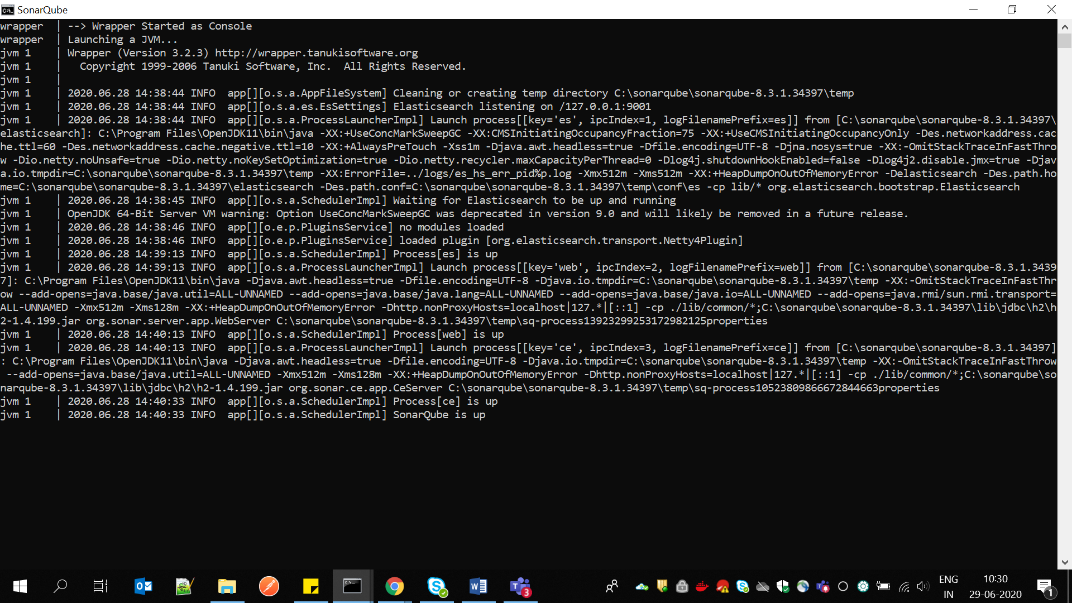

**Step 2** : **Integration of SonarQube in Jenkins**

* Login into Jenkins and install **SonarQube scanner** plugin

Go to **Manage Jenkins** –> **Manage Plugins** > **Available** –> **SonarQube scanner**and also add credentials plugins to store your credentials in Jenkins

* Configure SonarQube home path

Go to **Manage Jenkins** –> **Global Tool Configuration** –> **SonarQube Scanner**

1. Name : **sonarscanner**
2. SONAR_RUNNER_HOME : **C:\sonarqube\sonar-scanner-4.4.0.2170** (Your directory path of SonarQube)

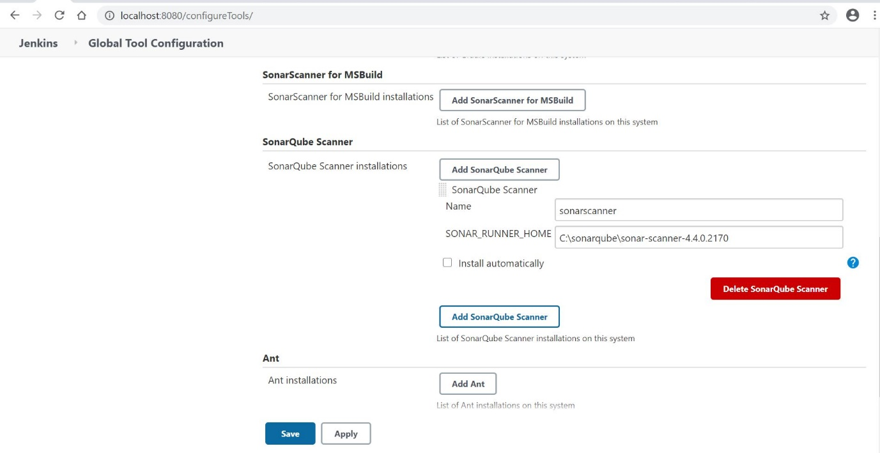

Go to **Manage Jenkins** –> **Configuration System** –> **SonarQube Server**

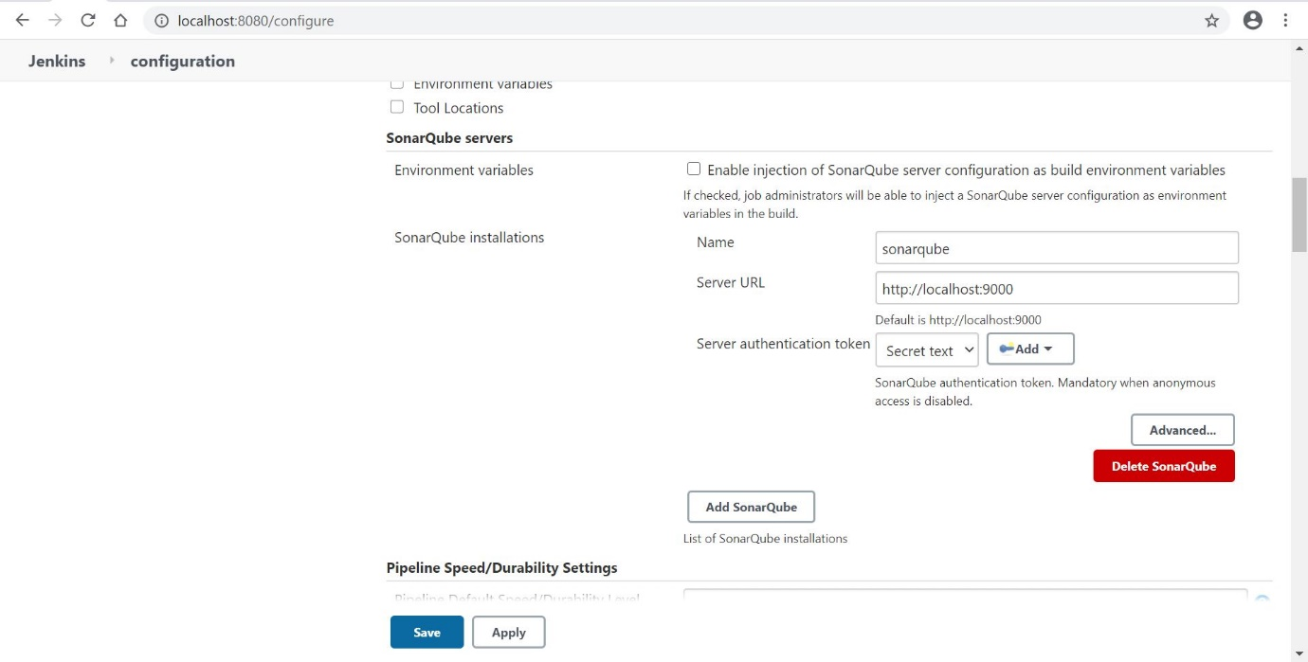

* Now, Configure SonarQube server in Jenkins

1. For integration, you need SonarQube Server authentication token in Jenkins

Log in into your SonarQube Server and find following under user bar  
Go to **My Account** –> **Security** –> **Generate Token.**

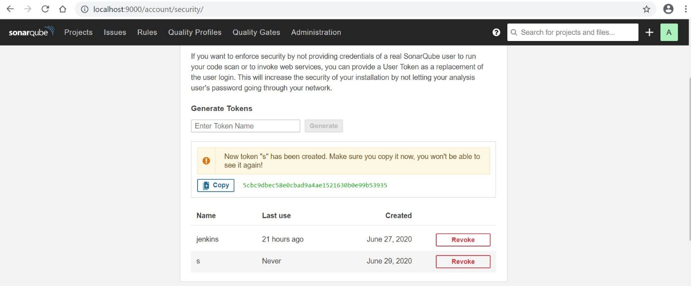

1. Go to **Manage Jenkins** –> **Configure Systems** –> **SonarQube Servers**
2. Name : **SonarQube**
3. Server URL : Not Required is same as default
4. Add server authentication token
5. Select it as a server authentication token

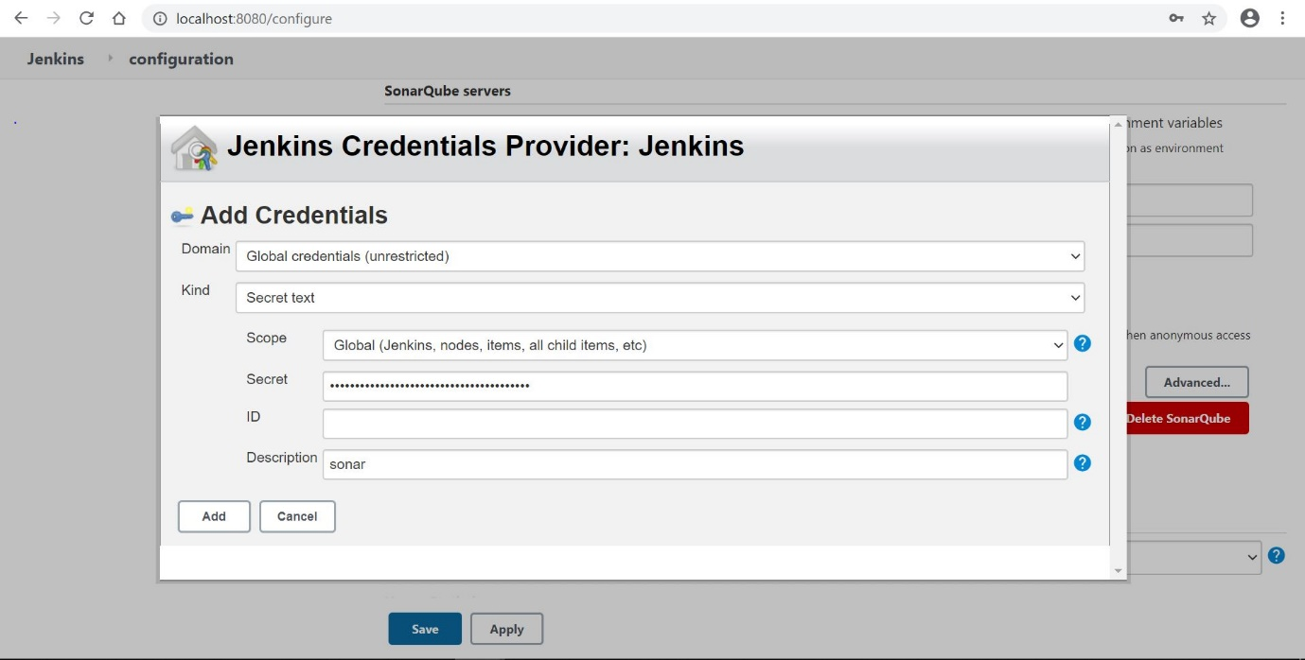

* Configure Sonar Scanner

Go to **project** –> **Configure** –> **Build**  –> **Execute Sonar Scanner**

**sonar.projectKey = JavaProject**

**sonar.projectName = JavaProject**

**sonar.projectVersion = 1.0**

**sonar.sources = C:\Users\kommahes\CollegePredictor\CollegePredictor**

**sonar.language = java**

**sonar.java.binaries = ./target/classes**

**sonar.tests = src/test**

**sonar.junit.reportsPath = ./target/surefire-reports**

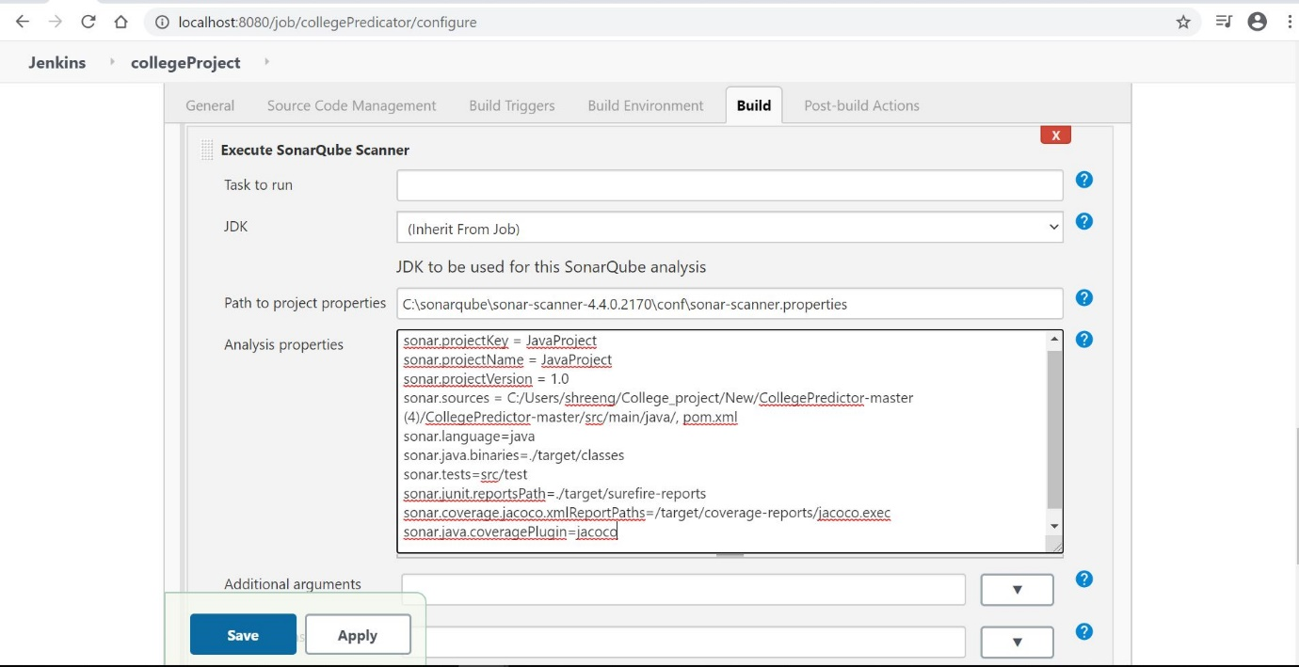

* Save it. Now, your SonarQube integration is completed with Jenkins. Create a job to test SonarQube and to generate a report of your project.

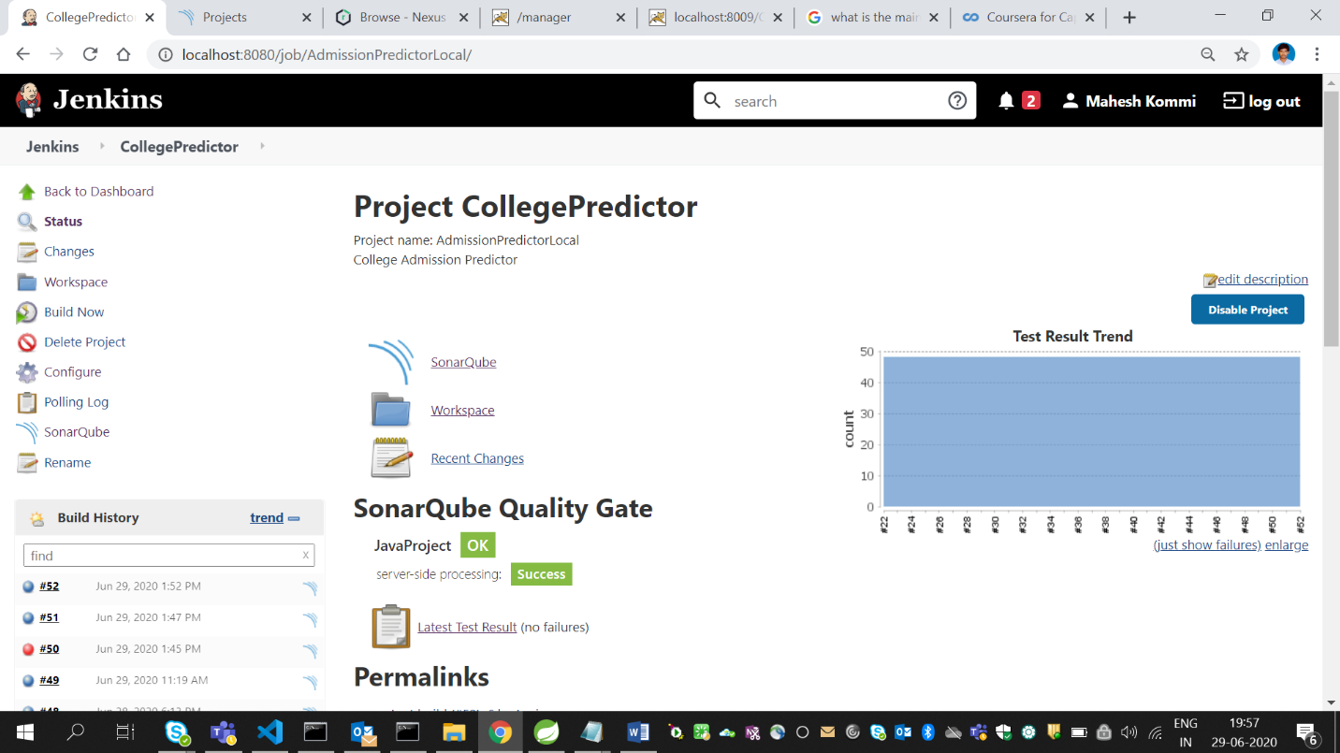

* When you login into SonarQube server, you will get analysis report of your code.

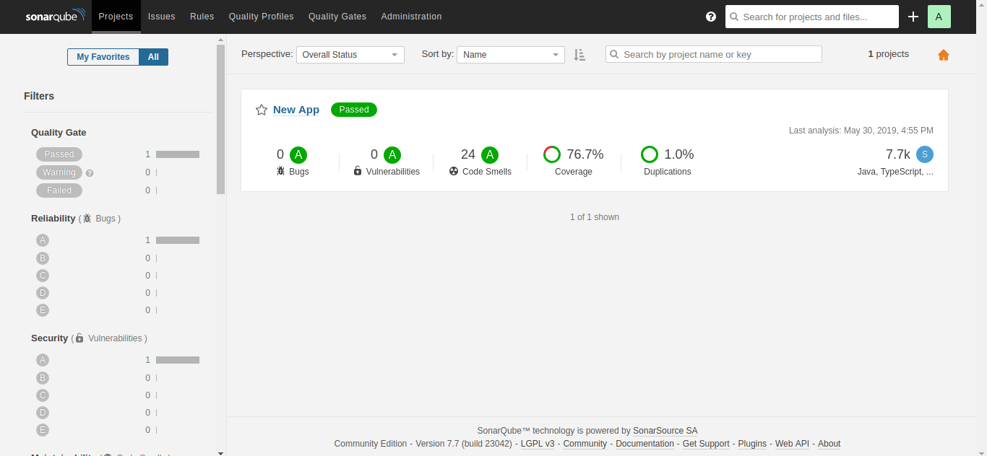

PIPELINE:

Pipeline Creation(Using Build Triggers with individual FreestyleProjects)

Firstly start with linking all the different jobs in the specific order that has to be triggered. To do that first identify the initial job and update the configurations.

In the **Post Build Action** select **Build Other Projects** and give the name of the job that has to be triggered after the completion of the present job and save the configurations.

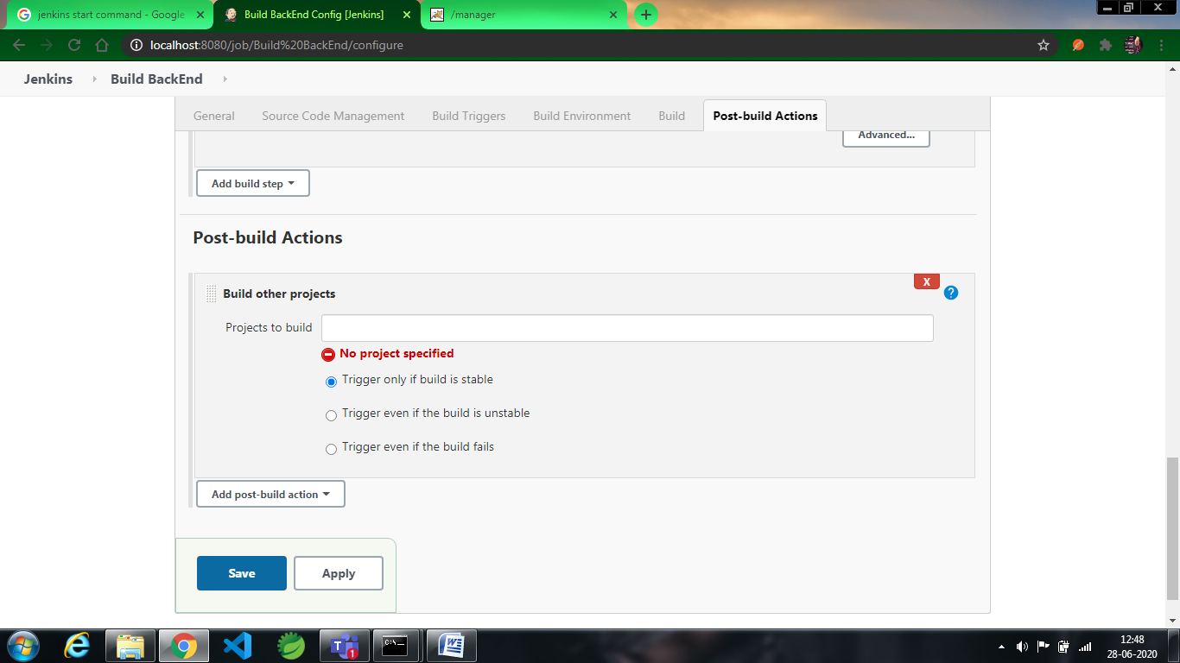

Continue updating all the configurations until the chain of triggers has been completed.

Then add the plugIn **Build PipeLine** from the Manage plugins available section and allow it to successfully added.

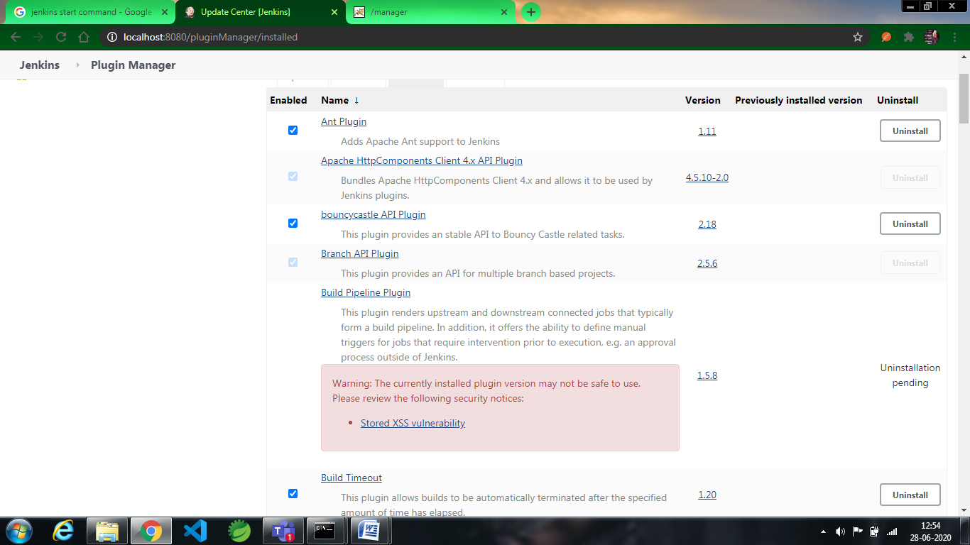

After adding the pipeline create the new pipeline and add the name of the pipeline in the **View name** section and select the option **Build PileLine view and** select ok.

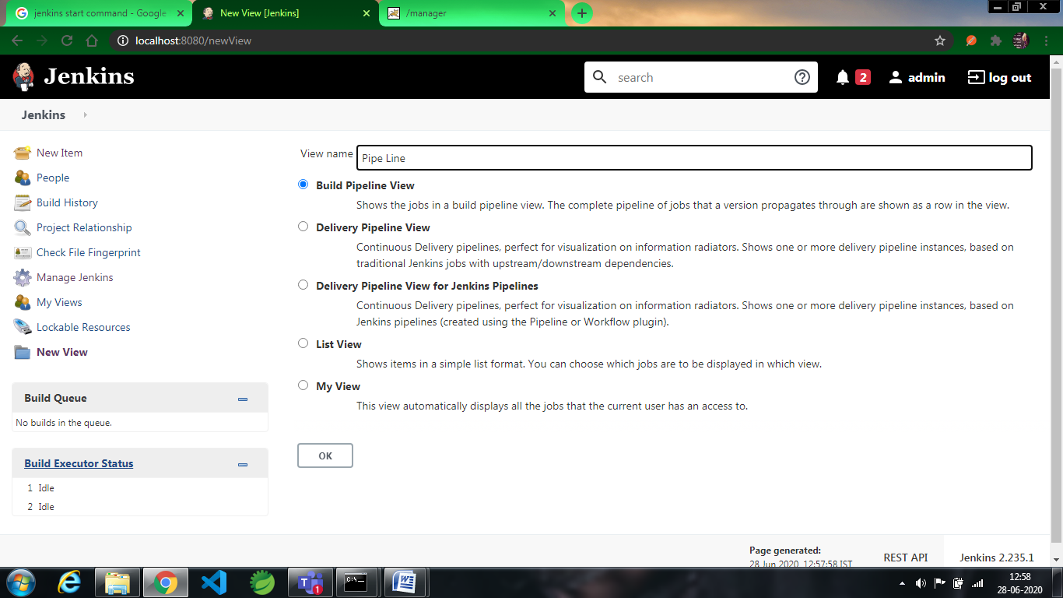

And later Add the description(optional) and in the bottom section you can find **PileLine**  **Flow** Section and in that **Select Initial Job** give the first job where the process has to start and press ok so that the changes are saved.

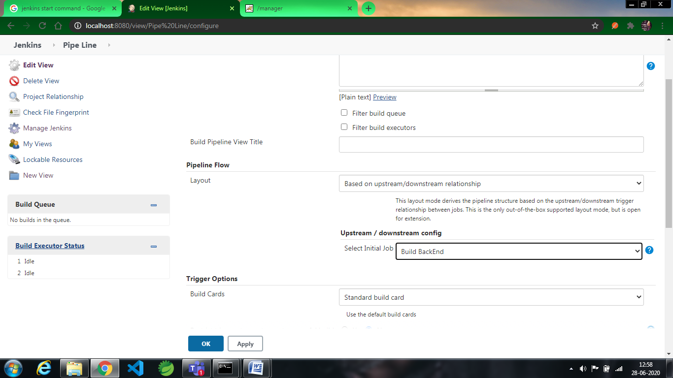

Now start the first job and open the pipleline you have created to find the status. You can find the below image where **Yellow** statesthat the process is going on while the rest of the jobs are held in the queue

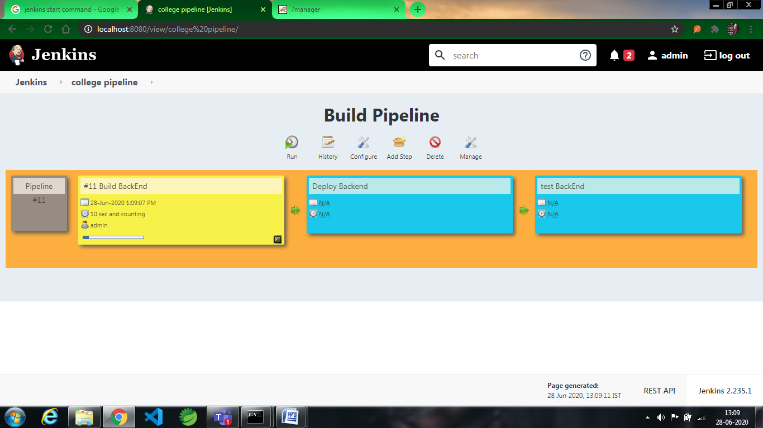The next job starts after completion of the ruuning job. **Green** colour states that the job is completed while **Blue** is for the jobs in the queue

You can find which job has been triggered in the process even in the console as below picture.

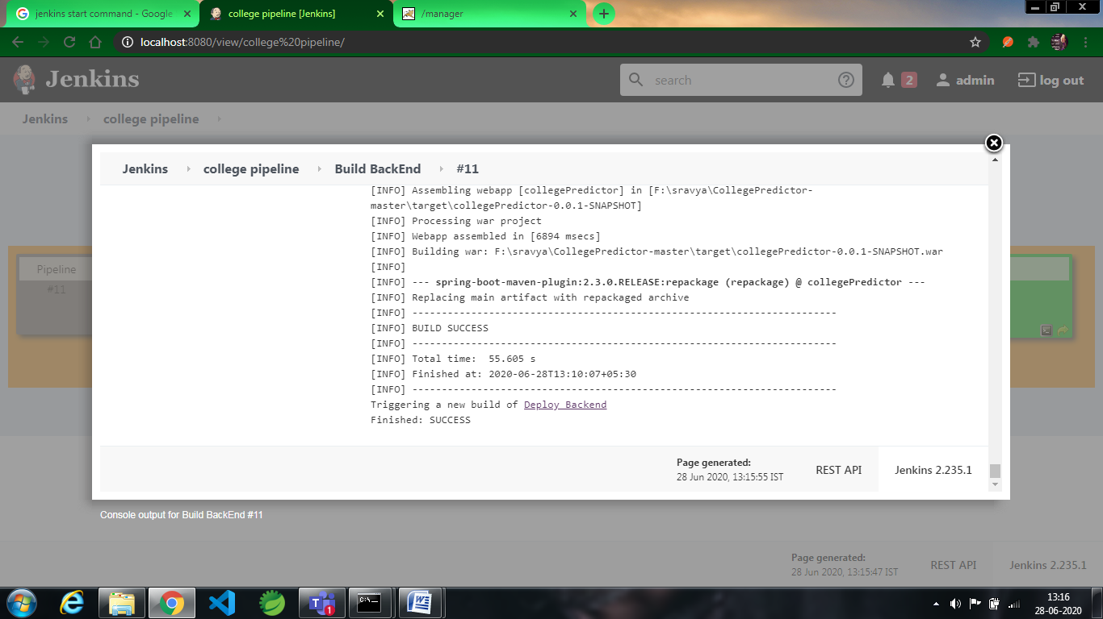

The process continues until all the jobs have been completed successfully. If there is any error/failure in any job then the flow of the pipleline breaks and do not process further.

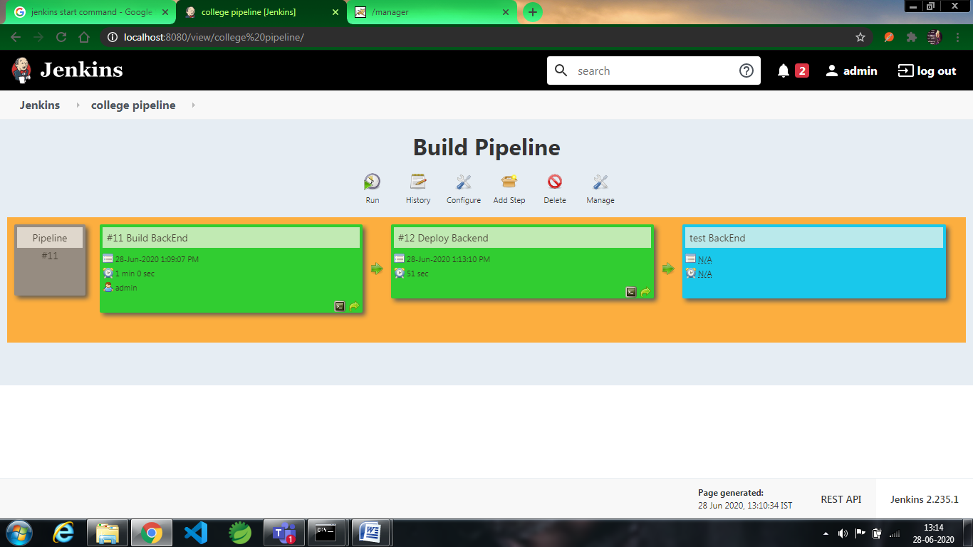

After completion of all the process you can find the below image and thus the flow of pipeline comes to an end.

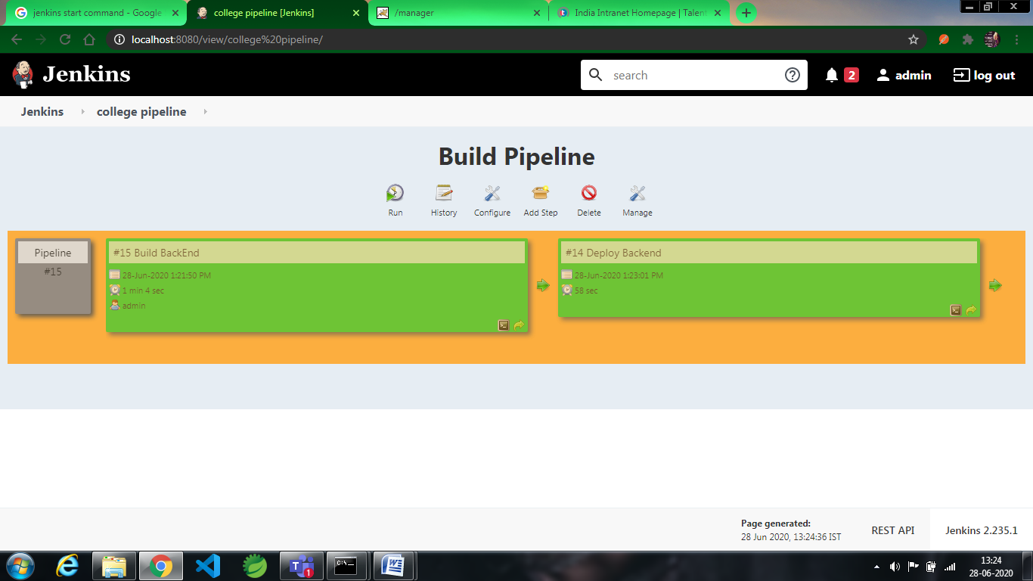

**PIPELINE CREATION USING SCRIPT :**

1. First, we need to install some plugins mainly two plugins they are:

*Delivery Pipeline Plugin

* Build Pipeline Plugin\

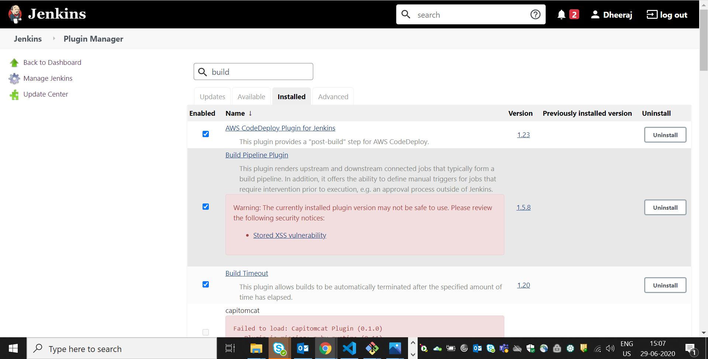

1. We need a create Pipeline Project

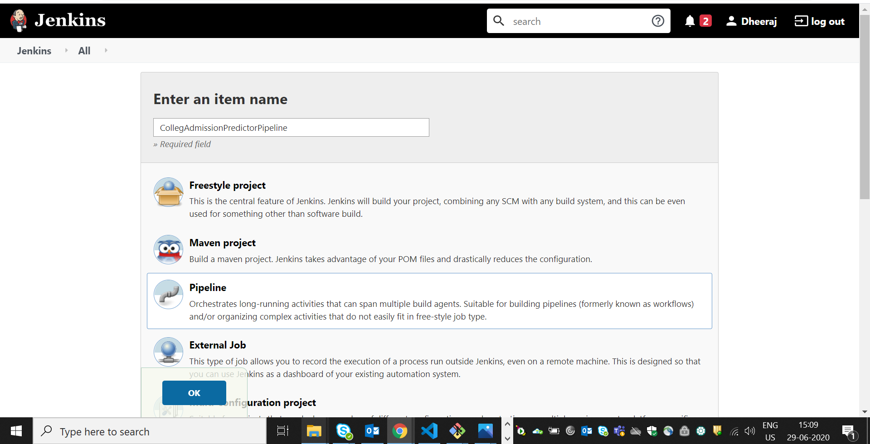

1. We need to configure poll scm(optional) :

Here 5 stars indicating 1 min

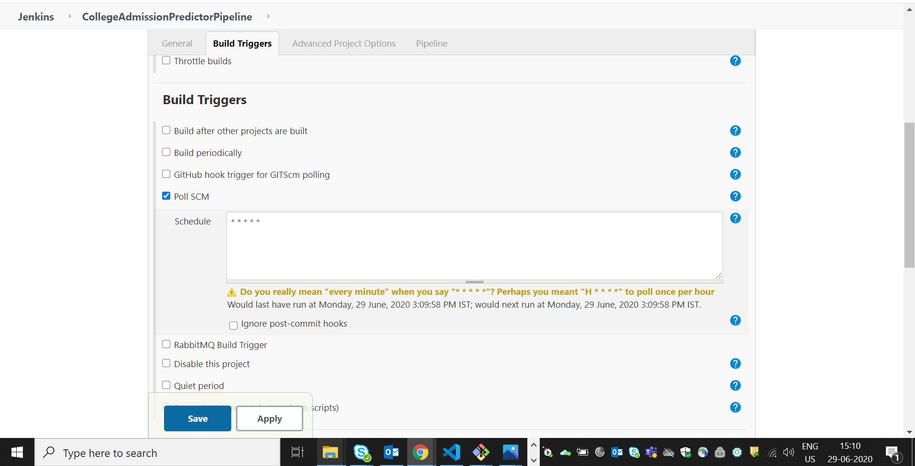

1. We need to write script to enable automatic build for each step we need to write script. In order to write script we can generate script by going in to Snippet Generator:

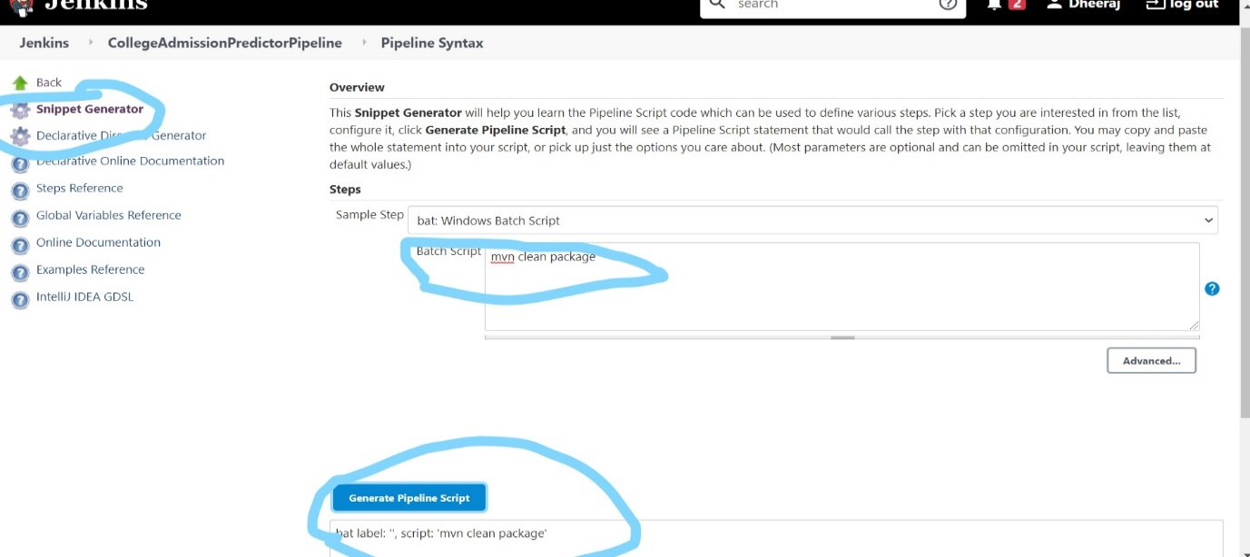

1. We need to write script or we can copy script from snippet generator:

node

{

dir('C:/Users/kommahes/CollegePredictor/CollegePredictor'){

stage('Build'){

bat label: '', script: 'mvn clean package'

}

stage('Testing'){

junit 'target\\surefire-reports/*.xml'

}

stage('SonarQube analysis') {

withSonarQubeEnv(installationName: 'SonarQube') {

bat 'mvn org.sonarsource.scanner.maven:sonar-maven-plugin:3.6.0.1398:sonar'

}

}

stage('Nexus'){

nexusArtifactUploader artifacts: [[artifactId: 'collegePredictor', classifier: '', file: 'target\\CollegePredictor.war', type: 'war']], credentialsId: '89bb6a2b-0409-4829-b1b8-718963dee600', groupId: 'com.caps', nexusUrl: 'localhost:8081', nexusVersion: 'nexus3', protocol: 'http', repository: 'maven-snapshots', version: '0.0.1-SNAPSHOT'

}

stage('Deploy'){

archiveArtifacts artifacts: 'target/*.war', followSymlinks: false

deploy adapters: [tomcat9(credentialsId: 'c1f4ed80-9510-4dc7-93c4-000384fa74d5', path: '', url: 'http://localhost:8009/')], contextPath: 'CollegePredictor', war: 'target\\CollegePredictor.war'

}

}

}

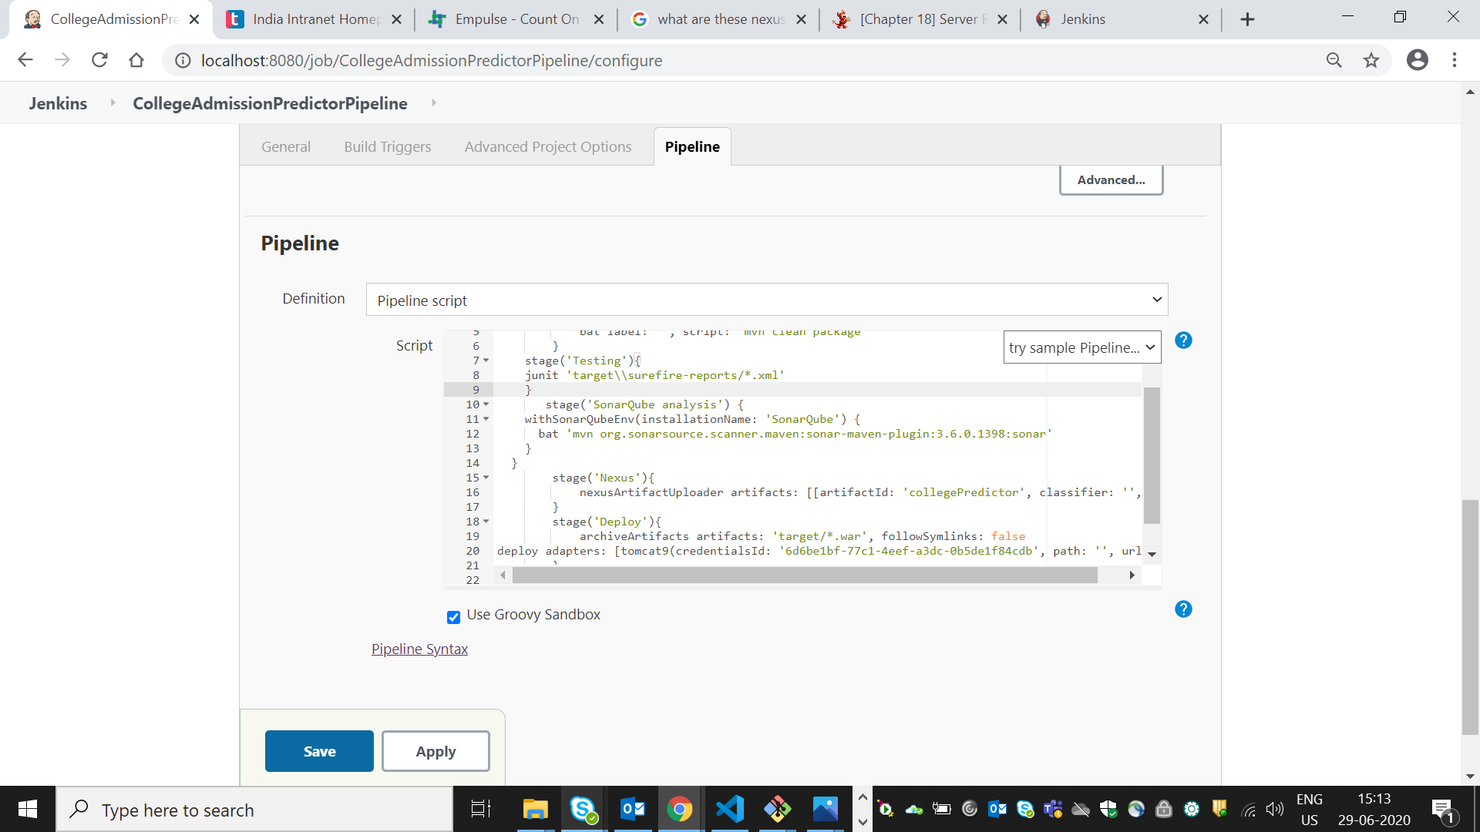

1. After completion it shows the stage view for various steps:

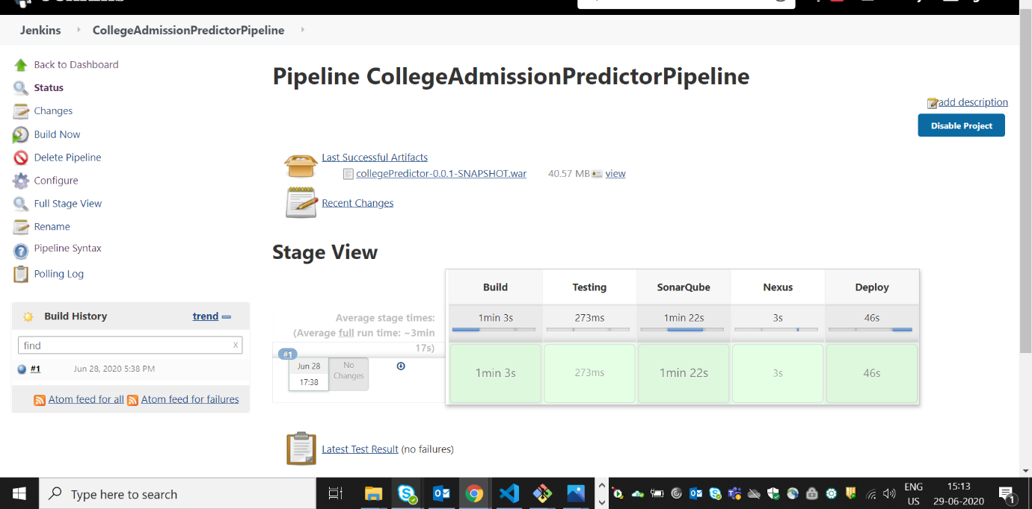

SONATYPE NEXUS:

Nexus is a repository manager. It allows you to proxy, collect, and manage your dependencies so that you are not constantly juggling a collection of JARs. It makes it easy to distribute your software. Internally, you configure your build to publish artifacts to Nexus and they then become available to other developers.

1. **Installation:**
   * Goto Nexus from <https://www.sonatype.com/download-oss-sonatype>
   * Select community version and download it
   * Extract .zip file

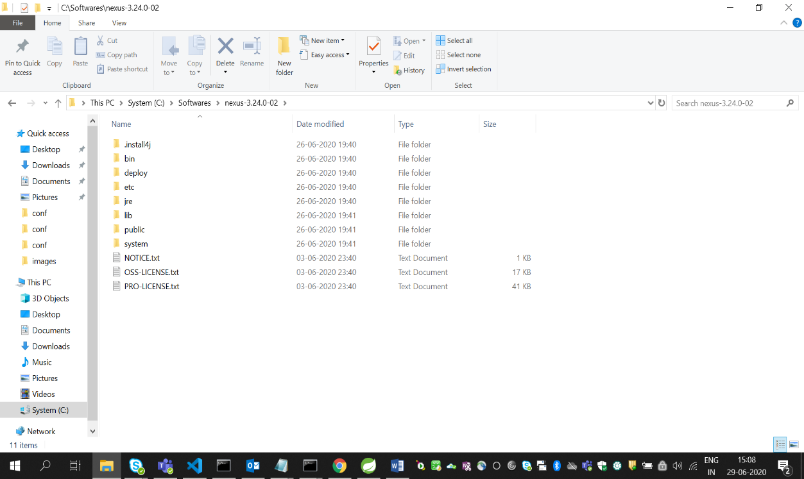

* Open Administrator command prompt
* Navigate to nexus path till bin 🡪 C:\Softwares\nexus-3.24.0-02\bin
* Execute the commands
  + - * nexus /install
      * nexus /start

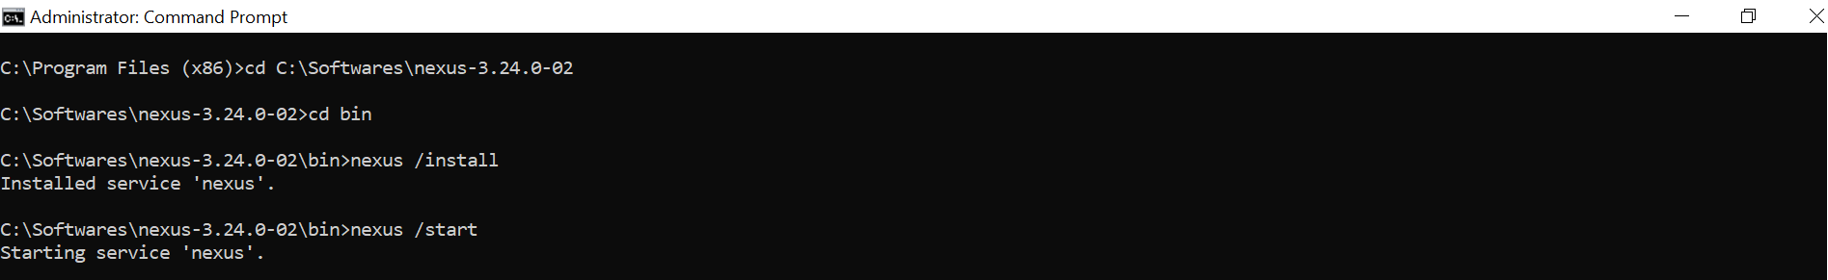

* Open <http://localhost:8081> in the browser
* We can see the below UI

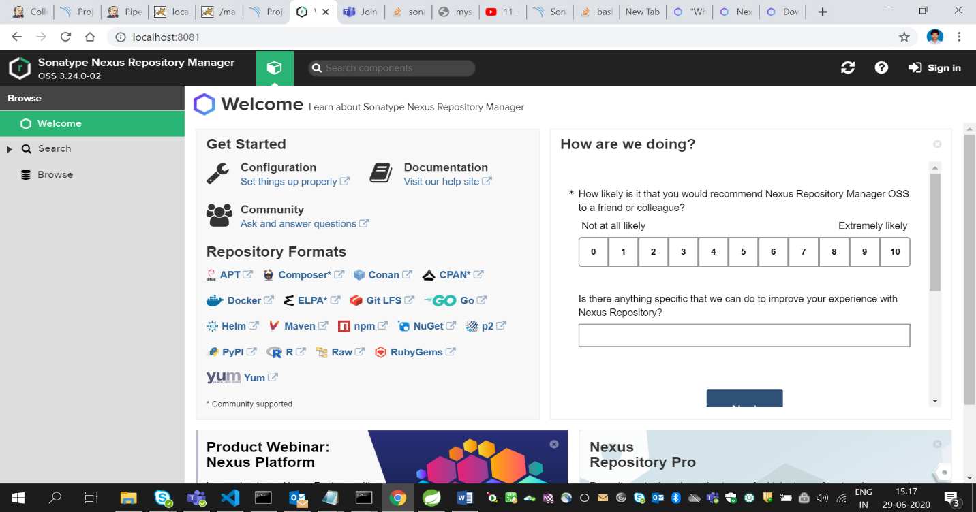

1. **Adding dependencies in pom.xml:**

* Add the below dependency in pom.xml

<distributionManagement>

<repository>

<id>deployment</id>

<name>maven-releases</name>

<url>http://localhost:8081/repository/maven-releases/</url>

</repository>

<snapshotRepository>

<id>deployment</id>

<name>maven-snapshots</name>

<url>http://localhost:8081/repository/maven-snapshots/</url>

</snapshotRepository>

</distributionManagement>

1. **Adding server in maven settings.xml:**

* Go to maven directory and open Conf folder then edit settings.xlm file and add below code.

**<server>**

**<id>1234</id>**

**<username>admin</username>**

**<password>admin</password>**

**</server>**

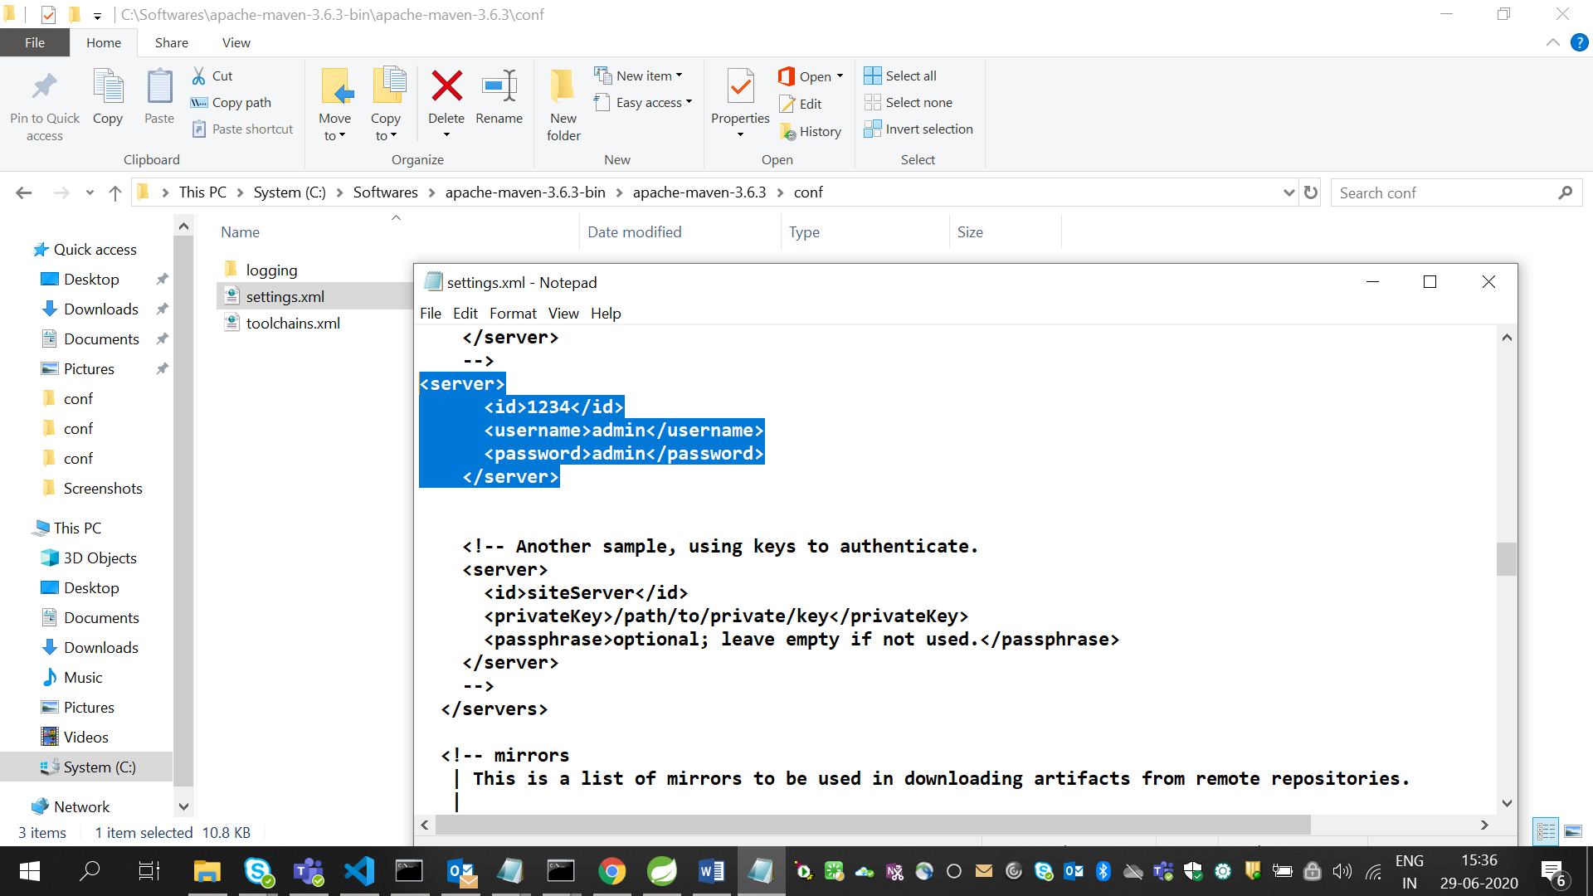

1. **Jenkins Configurtion:**

* Open Jenkins : <http://localhost:8080>
* Go to Manage Jenkins🡪Manage Plugins
  + Select available and search for nexus artefact uploader and install it.

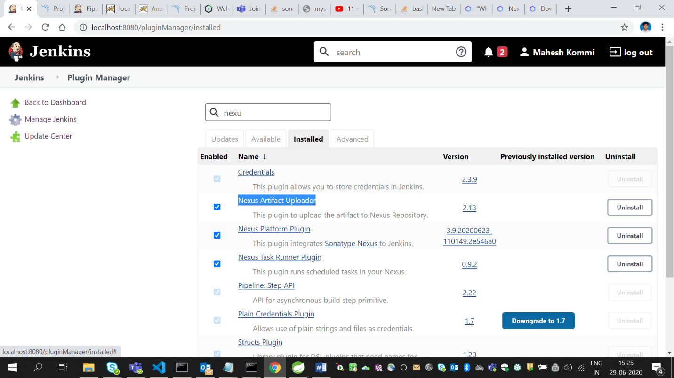

* Again go to Manage Jenkins🡪Configuration
* Look for SonaType Nexus
* Click on Add Nexus Repository Manager Server.
* Add the below configurations

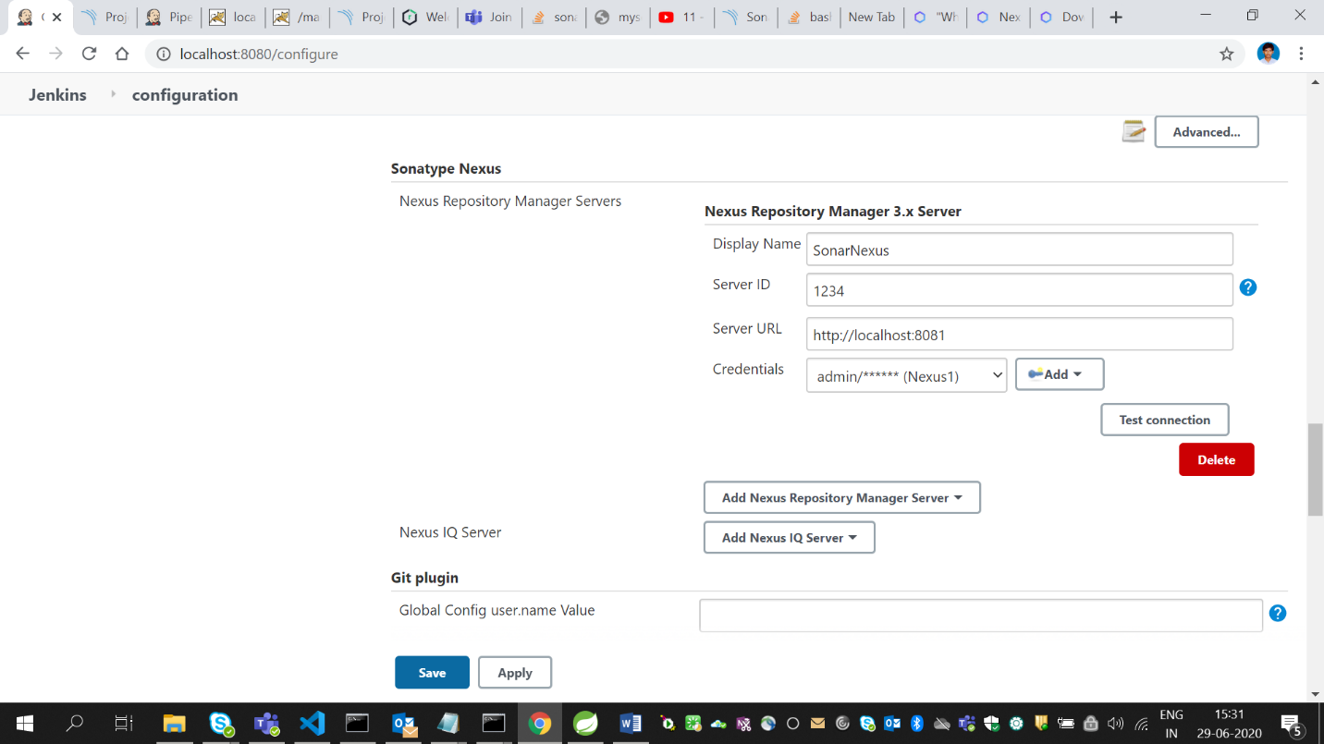

1. **Nexus Configuration in Jenkins Job:**

* Click on job in which we need to configured nexus
* Go to configure
* Go to Build
* Click on Add build Step
* Add the following configurations
* Then click apply 🡪 save

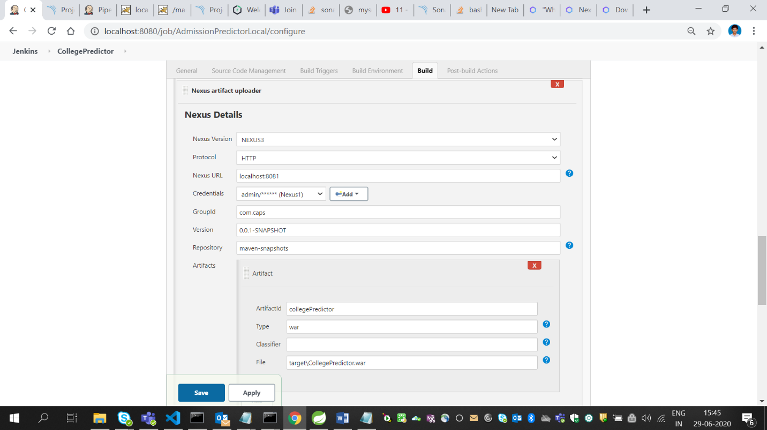

* Click on Build now
* Go to console output
* You can see artefact uploaded successfully in the last

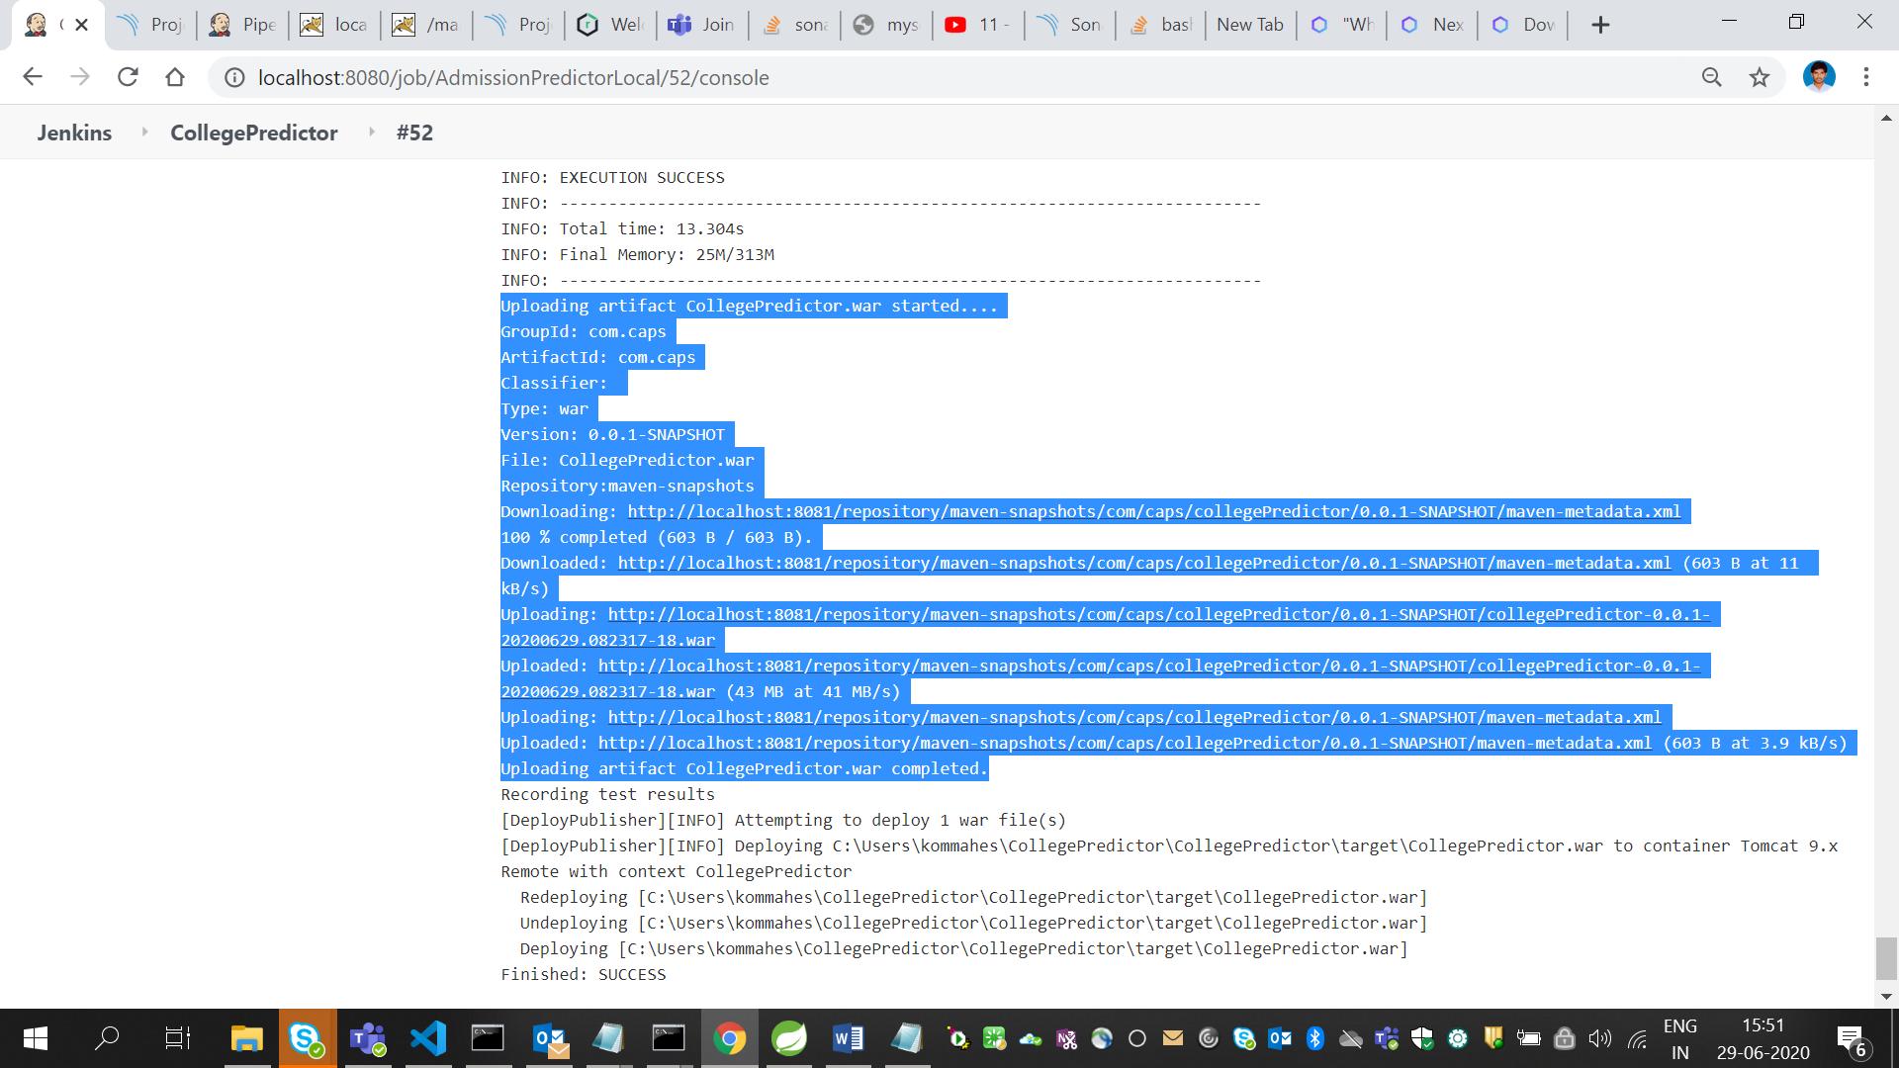

1. **Checkng the artifcats in Nexus:**

* Go to <http://localhost:8081>
* Go to Browse🡪maven-snapshots
* There we can find the uploaded articats

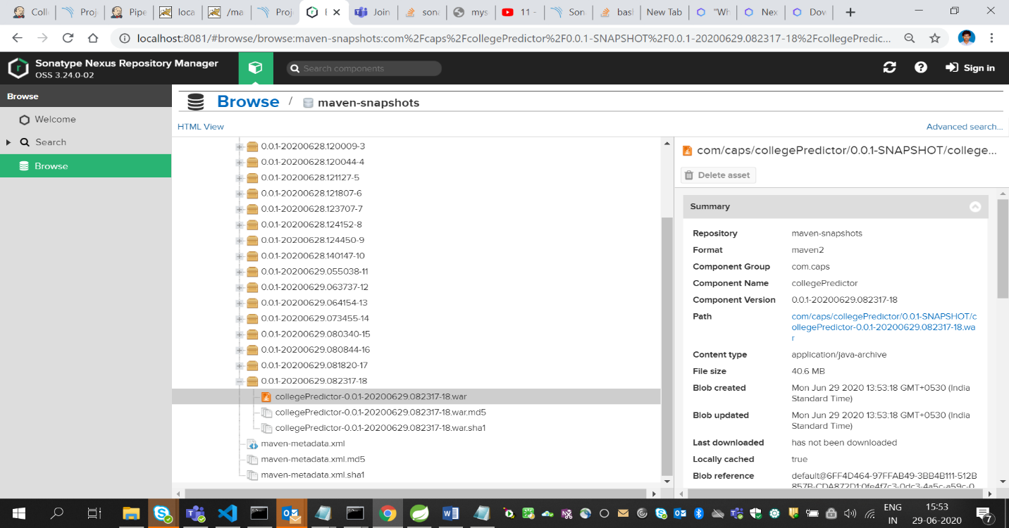

* **Nexus is successfully completed.**

JUNIT TESTCASE RESULTS:

**Installing plugin**

1. Open Jenkins
2. Go to manage jenkins🡪 manage plugins🡪 available
3. Search for Junit plugin
4. Install it

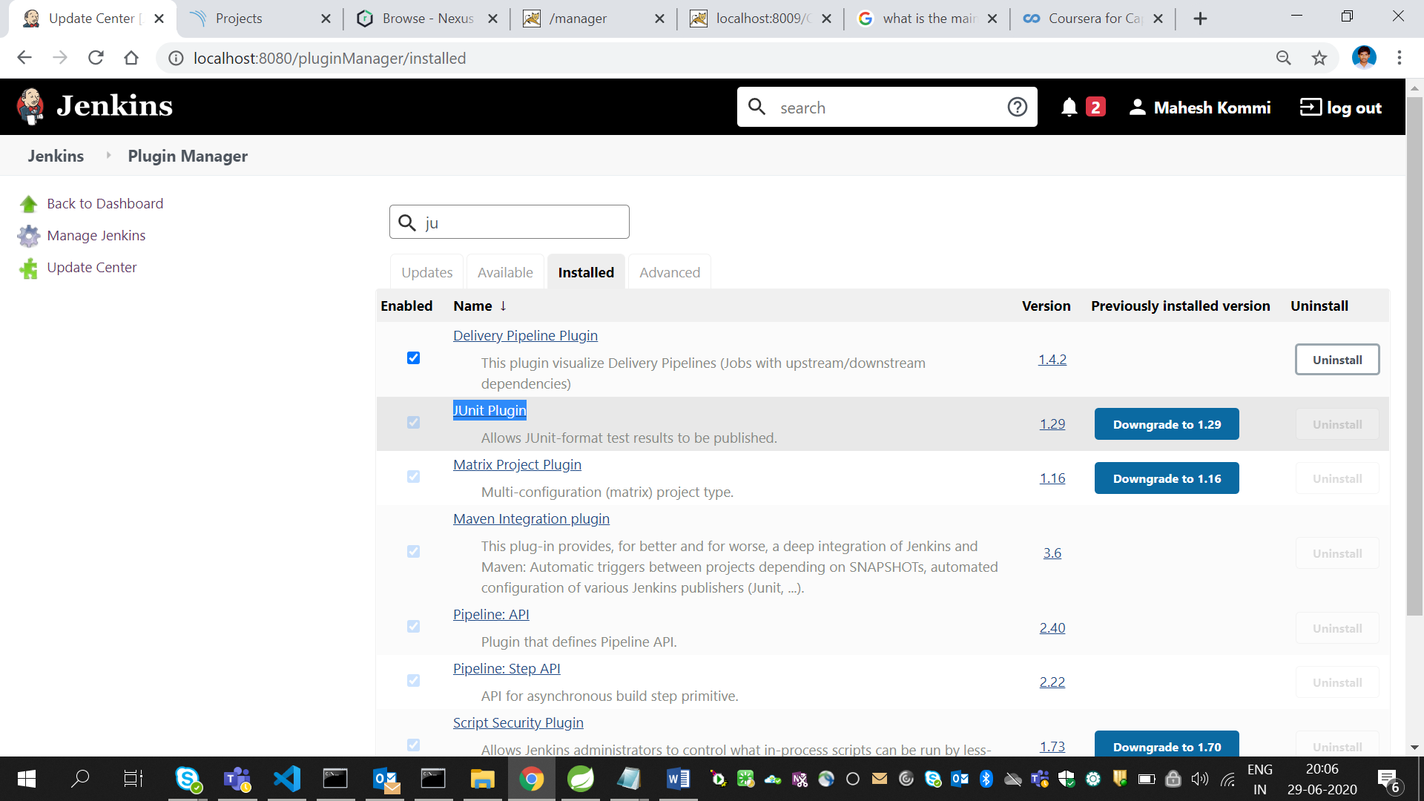

**Configuring Junit tests result report:**

1. Go to the project in which we need to configure Junit test results.
2. Go to configure 🡪 Post-build actions
3. Click on Add post build action button
4. Select publish JUnit Test Result Report.
5. The following configurations need to be done.

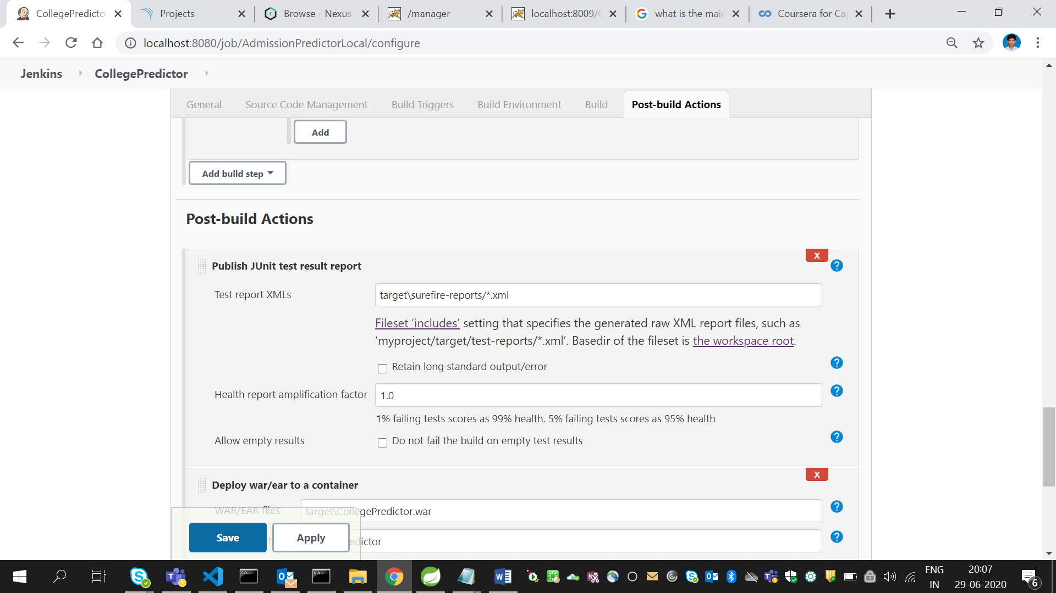

1. Click on apply then save
2. Click on build now
3. We will be able to see the following graph for test results

